Supplementary information 1
Quantification of free and cysteinylated aldehydes in samples derived from different stages of the industrial-scale malting process A

Compounds: 2MP = 2-methylpropanal, 2MB = 2-methylbutanal, 3MB = 3-methylbutanal, MET = methional, PHE = phenylacetaldehyde, FUR = furfural, HEX = hexanal, T2N = trans-2 nonenal, 2MP-CYS = cysteinylated 2-methylpropanal, 2MB-CYS = cysteinylated 2-methylbutanal, 3MB-CYS = cysteinylated 3-methylbutanal, MET-CYS = cysteinylated methional, PHE-CYS = cysteinylated phenylacetaldehyde, FUR-CYS = cysteinylated furfural (<LOD), and HEX-CYS = cysteinylated hexanal (cysteinylated trans-2-nonenal is not presented as the reference compound was not available).

Analysed samples: barley; GM = germinating barley (GM0 – onset of germination; GM1-GM4 = germinated for 1, 2, 3, 4 days, respectively); K = samples taken at kilning, after 12 up to 22h of kilning; C = samples taken at cooling, after 0 min to 50 min; FIN = finished malt (without rootlets). During kilning samples were collected from top, middle and bottom grain bed layer, while during cooling samples were taken from top layer.

Results are expressed as mean values (n=3) ± standard deviation. LOD = limit of detection; LOQ = limit of quantification.
Table S1.1. Quantification of free aldehydes in samples derived from different stages of the industrial-scale malting process A.
Free aldehydes  (µg/kg dm) | 2MP |  |  | 2MB |  |  | 3MB
Raw material
Barley | <LOD (35) |  |  | <LOD (30) |  |  | <LOD (136)
Germination
GM0 | <LOD (35) |  |  | <LOD (30) |  |  | <LOD (136)
GM1 | <LOD (35) |  |  | <LOD (30) |  |  | <LOD (136)
GM2 | <LOQ (117) |  |  | <LOD (30) |  |  | <LOD (136)
GM3 | 125 ± 22 |  |  | <LOD (30) |  |  | <LOD (136)
GM4 | 187 ± 24 |  |  | <LOD (30) |  |  | <LOD (136)
Kilning
 | Bottom | Middle | Top | Bottom | Middle | Top | Bottom | Middle | Top
K12.0 | <LOQ (117) | <LOQ (117) | <LOD (35) | <LOD (30) | <LOD (30) | <LOD (30) | <LOQ (454) | <LOD (136) | <LOD (136)
K14.0 | <LOQ (117) | <LOQ (117) | <LOD (35) | <LOD (30) | <LOD (30) | <LOD (30) | <LOQ (454) | <LOQ (454) | <LOD (136)
K16.0 | 142 ± 13 | 104 ± 16 | <LOD (35) | <LOQ (99) | <LOQ (99) | <LOD (30) | <LOQ (454) | <LOQ (454) | <LOD (136)
K18.0 | 199 ± 5 | 163 ± 25 | <LOD (35) | 109 ± 9 | <LOQ (99) | <LOD (30) | <LOQ (454) | <LOQ (454) | <LOD (136)
K18.5 | 183 ± 28 | 165 ± 26 | <LOQ (117) | 107 ± 22 | <LOQ (99) | <LOD (30) | <LOQ (454) | <LOQ (454) | <LOD (136)
K19.0 | 236 ± 24 | 161 ± 21 | <LOQ (117) | 148 ± 35 | <LOQ (99) | <LOQ (99) | <LOQ (454) | <LOQ (454) | <LOD (136)
K19.5 | 277 ± 33 | 252 ± 13 | <LOQ (117) | 173 ± 43 | 131 ± 13 | <LOQ (99) | <LOQ (454) | <LOQ (454) | <LOD (136)
K20.0 | 352 ± 5 | 305 ± 10 | <LOQ (117) | 220 ± 19 | 207 ± 30 | <LOQ (99) | <LOQ (454) | <LOQ (454) | <LOD (136)
K20.5 | 347 ± 37 | 326 ± 25 | <LOQ (117) | 244 ± 35 | 209 ± 28 | <LOQ (99) | <LOQ (454) | <LOQ (454) | <LOQ (454)
K21.0 | 438 ± 1 | 333 ± 61 | <LOQ (117) | 296 ± 19 | 226 ± 21 | <LOQ (99) | 563 ± 34 | <LOQ (454) | <LOQ (454)
K21.5 | 504 ± 58 | - | <LOQ (117) | 380 ± 49 | - | <LOQ (99) | 670 ± 78 | - | <LOQ (454)
K22.0/C0 | 633 ± 48 | 570 ± 60 | 126 ± 12 | 520 ± 26 | 455 ± 19 | 131 ± 10 | 860 ± 37 | 783 ±23 | <LOQ (454)
Cooling
 | Top |  |  | Top |  |  | Top
C15 | 401 ± 28 |  |  | 300 ± 10 |  |  | 598 ± 29
C30 | 417 ± 26 |  |  | 282 ± 45 |  |  | 549 ± 92
C40 | 300 ± 36 |  |  | 273 ± 30 |  |  | 451 ± 72
C50 | 354 ± 49 |  |  | 294 ± 13 |  |  | 527 ± 61
Finished product
Malt | 375 ± 16 |  |  | 370 ± 25 |  |  | 655 ± 45

Table S1.2. Quantification of free aldehydes in samples derived from different stages of the industrial-scale malting process A.
Free aldehydes  (µg/kg dm) | MET |  |  | PHE |  |  | FUR
Raw material
Barley | <LOD (18) |  |  | <LOD (32) |  |  | <LOD (17)
Germination
GM0 | <LOD (18) |  |  | <LOQ (107) |  |  | <LOD (17)
GM1 | <LOD (18) |  |  | <LOQ (107) |  |  | <LOD (17)
GM2 | <LOD (18) |  |  | <LOQ (107) |  |  | <LOD (17)
GM3 | <LOD (18) |  |  | <LOQ (107) |  |  | <LOD (17)
GM4 | <LOD (18) |  |  | <LOQ (107) |  |  | <LOD (17)
Kilning
 | Bottom | Middle | Top | Bottom | Middle | Top | Bottom | Middle | Top
K12.0 | <LOD (18) | <LOD (18) | <LOD (18) | <LOQ (107) | <LOQ (107) | <LOQ (107) | <LOD (17) | <LOD (17) | <LOD (17)
K14.0 | <LOD (18) | <LOD (18) | <LOD (18) | <LOQ (107) | <LOQ (107) | <LOQ (107) | <LOD (17) | <LOD (17) | <LOD (17)
K16.0 | <LOD (18) | <LOD (18) | <LOD (18) | 112 ± 6 | <LOQ (107) | <LOQ (107) | <LOD (17) | <LOD (17) | <LOD (17)
K18.0 | <LOD (18) | <LOD (18) | <LOD (18) | 161 ± 25 | 124 ± 15 | <LOQ (107) | <LOD (17) | <LOD (17) | <LOD (17)
K18.5 | <LOD (18) | <LOD (18) | <LOD (18) | 134 ±15 | 108 ± 18 | <LOQ (107) | <LOD (17) | <LOD (17) | <LOD (17)
K19.0 | <LOD (18) | <LOD (18) | <LOD (18) | 167 ± 28 | 112 ± 15 | <LOQ (107) | 58 ± 17 | <LOD (17) | <LOD (17)
K19.5 | <LOD (18) | <LOD (18) | <LOD (18) | 171 ± 38 | 153 ± 22 | <LOQ (107) | 55 ± 23 | 58 ± 9 | <LOD (17)
K20.0 | <LOD (18) | <LOD (18) | <LOD (18) | 256 ± 33 | 218 ± 36 | <LOQ (107) | 76 ± 18 | 75 ± 12 | <LOQ (58)
K20.5 | <LOD (18) | <LOD (18) | <LOD (18) | 244 ± 39 | 240 ± 55 | <LOQ (107) | 83 ± 10 | 80 ± 15 | <LOQ (58)
K21.0 | <LOD (18) | <LOD (18) | <LOD (18) | 338 ± 52 | 284 ± 38 | <LOQ (107) | 111 ± 24 | 86 ± 11 | <LOQ (58)
K21.5 | 90 ± 12 | <LOD (18) | <LOD (18) | 370 ± 57 | - | <LOQ (107) | 106 ± 20 | - | 74 ± 18
K22.0/C0 | 108 ± 31 | <LOD (18) | <LOD (18) | 524 ± 81 | 508 ± 72 | 175 ± 68 | 182 ± 32 | 141 ± 26 | 87 ± 5
Cooling
 | Top |  |  | Top |  |  | Top
C15 | <LOQ (59) |  |  | 303 ± 28 |  |  | 159 ± 22
C30 | <LOQ (59) |  |  | 284 ± 59 |  |  | 152 ± 23
C40 | <LOQ (59) |  |  | 200 ± 44 |  |  | 151 ± 14
C50 | <LOQ (59) |  |  | 243 ± 67 |  |  | 156 ± 12
Finished product
Malt | 71 ± 11 |  |  | 380 ± 39 |  |  | 176 ± 16

Table S1.3. Quantification of free aldehydes in samples derived from different stages of the industrial-scale malting process A.
Free aldehydes  (µg/kg dm) | HEX |  |  | T2N
Raw material
Barley | <LOD (47) |  |  | <LOD (37)
Germination
GM0 | <LOD (47) |  |  | <LOD (37)
GM1 | <LOQ (157) |  |  | <LOD (37)
GM2 | <LOQ (157) |  |  | <LOQ (123)
GM3 | 172 ± 26 |  |  | <LOQ (123)
GM4 | 337 ± 73 |  |  | <LOQ (123)
Kilning
 | Bottom | Middle | Top | Bottom | Middle | Top
K12.0 | 509 ± 74 | 570 ± 61 | 310 ± 50 | <LOQ (123) | <LOQ (123) | <LOQ (123)
K14.0 | 587 ± 5 | 571 ± 26 | 345 ± 50 | <LOQ (123) | <LOQ (123) | <LOQ (123)
K16.0 | 463 ± 60 | 575 ± 25 | 356 ± 51 | <LOQ (123) | <LOQ (123) | <LOQ (123)
K18.0 | 278 ± 50 | 356 ± 28 | 385 ± 32 | <LOQ (123) | <LOQ (123) | <LOQ (123)
K18.5 | 302 ± 42 | 317 ± 48 | 257 ± 31 | <LOQ (123) | <LOQ (123) | <LOQ (123)
K19.0 | 541 ± 85 | 365 ± 68 | 224 ± 30 | <LOQ (123) | <LOQ (123) | <LOQ (123)
K19.5 | 500 ± 74 | 535 ± 32 | 294 ± 43 | <LOQ (123) | <LOQ (123) | <LOQ (123)
K20.0 | 481 ± 51 | 440 ± 101 | 367 ± 46 | 129 ± 15 | <LOQ (123) | <LOQ (123)
K20.5 | 443 ± 69 | 434 ± 42 | 294 ± 47 | 137 ± 19 | 127 ± 16 | <LOQ (123)
K21.0 | 465 ± 76 | 447 ± 53 | 228 ± 28 | 155 ± 25 | 126 ± 19 | <LOQ (123)
K21.5 | 486 ± 62 | - | 253 ± 34 | 194 ± 21 | 126 ± 17 | <LOQ (123)
K22.0/C0 | 301 ± 71 | 441 ± 56 | 245 ± 37 | 215 ± 27 | 165 ± 27 | 126 ± 34
Cooling
 | Top |  |  | Top
C15 | 366 ± 43 |  |  | 178 ± 31
C30 | 305 ± 43 |  |  | 161 ± 26
C40 | 271 ± 37 |  |  | 141 ± 10
C50 | 319 ± 80 |  |  | 136 ± 12
Finished product
Malt | 191 ± 29 |  |  | 124 ± 15

Table S1.4. Quantification of cysteinylated aldehydes in samples derived from different stages of the industrial-scale malting process A.
Cysteinylated aldehydes  (µg/kg dm) | 2MP-CYS |  |  | 2MB-CYS |  |  | 3MB-CYS
Raw material
Barley | <LOD (25) |  |  | <LOD (5) |  |  | <LOD (24)
Germination
GM0 | <LOD (25) |  |  | <LOD (5) |  |  | <LOD (24)
GM1 | <LOD (25) |  |  | <LOD (5) |  |  | <LOD (24)
GM2 | <LOD (25) |  |  | <LOD (5) |  |  | <LOD (24)
GM3 | <LOD (25) |  |  | <LOD (5) |  |  | <LOD (24)
GM4 | <LOD (25) |  |  | <LOD (5) |  |  | <LOD (24)
Kilning
 | Bottom | Middle | Top | Bottom | Middle | Top | Bottom | Middle | Top
K12.0 | <LOQ (83) | <LOD (25) | <LOD (25) | <LOD (5) | <LOD (5) | <LOD (5) | <LOD (24) | <LOD (24) | <LOD (24)
K14.0 | <LOQ (83) | <LOD (25) | <LOD (25) | <LOD (5) | <LOD (5) | <LOD (5) | <LOD (24) | <LOD (24) | <LOD (24)
K16.0 | <LOQ (83) | <LOD (25) | <LOD (25) | <LOD (5) | <LOD (5) | <LOD (5) | <LOD (24) | <LOQ (48) | <LOD (24)
K18.0 | <LOQ (83) | <LOD (25) | <LOD (25) | <LOQ (17) | <LOD (5) | <LOD (5) | <LOQ (48) | <LOQ (48) | <LOD (24)
K18.5 | <LOQ (83) | <LOQ (83) | <LOD (25) | <LOQ (17) | <LOQ (17) | <LOD (5) | <LOQ (48) | <LOQ (48) | <LOD (24)
K19.0 | <LOQ (83) | <LOQ (83) | <LOD (25) | <LOQ (17) | <LOQ (17) | <LOD (5) | <LOQ (48) | <LOQ (48) | <LOD (24)
K19.5 | <LOQ (83) | <LOQ (83) | <LOD (25) | <LOQ (17) | <LOQ (17) | <LOD (5) | <LOQ (48) | <LOQ (48) | <LOD (24)
K20.0 | <LOQ (83) | <LOQ (83) | <LOD (25) | <LOQ (17) | <LOQ (17) | <LOD (5) | 52 ± 3 | <LOQ (48) | <LOQ (48)
K20.5 | <LOQ (83) | <LOQ (83) | <LOD (25) | 19 ± 1 | 20 ± 2 | <LOD (5) | 68 ± 10 | 78 ± 2 | <LOQ (48)
K21.0 | <LOQ (83) | <LOQ (83) | <LOD (25) | 20 ± 2 | 22 ± 4 | <LOD (5) | 74 ± 2 | 85 ± 9 | <LOQ (48)
K21.5 | <LOQ (83) | <LOQ (83) | <LOD (25) | 29 ± 1 | 27 ± 3 | <LOQ (17) | 123 ± 12 | 93 ± 5 | <LOQ (48)
K22.0/C0 | <LOQ (83) | <LOQ (83) | <LOD (25) | 38 ± 4 | 44 ± 3 | <LOQ (17) | 180 ± 6 | 202 ± 7 | 53 ± 3
Cooling
 | Top |  |  | Top |  |  | Top
C15 | 111 ± 26 |  |  | 25 ± 1 |  |  | 109 ± 8
C30 | 127 ± 9 |  |  | 23 ± 1 |  |  | 97 ± 5
C40 | 153 ± 18 |  |  | 21 ± 2 |  |  | 89 ± 5
C50 | 199 ± 30 |  |  | 20 ± 2 |  |  | 87 ± 5
Finished product
Malt | 92 ± 6 |  |  | 36 ± 3 |  |  | 218 ± 20

Table S1.5. Quantification of cysteinylated aldehydes in samples derived from different stages of the industrial-scale malting process A.
Cysteinylated aldehydes  (µg/kg dm) | MET-CYS |  |  | PHE-CYS |  |  | HEX-CYS
Raw material
Barley | <LOD (7) |  |  | <LOD (11) |  |  | <LOD (14)
Germination
GM0 | <LOD (7) |  |  | <LOD (11) |  |  | <LOD (14)
GM1 | <LOD (7) |  |  | <LOD (11) |  |  | <LOD (14)
GM2 | <LOD (7) |  |  | <LOD (11) |  |  | <LOQ (47)
GM3 | <LOD (7) |  |  | <LOD (11) |  |  | <LOQ (47)
GM4 | <LOD (7) |  |  | <LOD (11) |  |  | <LOQ (47)
Kilning
 | Bottom | Middle | Top | Bottom | Middle | Top | Bottom | Middle | Top
K12.0 | <LOD (7) | <LOD (7) | <LOD (7) | <LOD (11) | <LOD (11) | <LOD (11) | <LOD (14) | <LOD (14) | <LOQ (47)
K14.0 | <LOD (7) | <LOD (7) | <LOD (7) | <LOD (11) | <LOD (11) | <LOD (11) | <LOD (14) | <LOD (14) | <LOQ (47)
K16.0 | <LOD (7) | <LOD (7) | <LOD (7) | <LOD (11) | <LOQ (36) | <LOD (11) | <LOD (14) | <LOD (14) | <LOQ (47)
K18.0 | <LOD (7) | <LOD (7) | <LOD (7) | <LOQ (36) | <LOQ (36) | <LOD (11) | <LOD (14) | <LOQ (47) | <LOQ (47)
K18.5 | <LOD (7) | <LOD (7) | <LOD (7) | <LOQ (36) | <LOQ (36) | <LOD (11) | <LOD (14) | <LOQ (47) | <LOQ (47)
K19.0 | <LOD (7) | <LOD (7) | <LOD (7) | <LOQ (36) | <LOQ (36) | <LOD (11) | <LOQ (47) | <LOQ (47) | <LOQ (47)
K19.5 | <LOD (7) | <LOD (7) | <LOD (7) | 37 ± 3 | <LOQ (36) | <LOD (11) | <LOQ (47) | <LOQ (47) | <LOQ (47)
K20.0 | <LOD (7) | <LOD (7) | <LOD (7) | 45 ± 1 | 38 ± 3 | <LOQ (36) | <LOQ (47) | <LOQ (47) | <LOQ (47)
K20.5 | <LOQ (25) | <LOD (7) | <LOD (7) | 50 ± 4 | 49 ± 4 | <LOQ (36) | <LOQ (47) | <LOQ (47) | <LOQ (47)
K21.0 | <LOQ (25) | <LOD (7) | <LOD (7) | 64 ± 5 | 50 ± 2 | <LOQ (36) | <LOQ (47) | <LOQ (47) | <LOQ (47)
K21.5 | <LOQ (25) | <LOQ (25) | <LOD (7) | 77 ± 6 | 71 ± 1 | 37 ± 2 | <LOQ (47) | <LOQ (47) | <LOQ (47)
K22.0/C0 | 32 ± 2 | <LOQ (25) | <LOD (7) | 102 ± 2 | 101 ± 2 | 41 ± 2 | <LOQ (47) | 48 ± 1 | <LOQ (47)
Cooling
 | Top |  |  | Top |  |  | Top
C15 | 25 ± 1 |  |  | 63 ± 5 |  |  | <LOQ (47)
C30 | 21 ± 1 |  |  | 57 ± 3 |  |  | <LOQ (47)
C40 | 20 ± 2 |  |  | 58 ± 3 |  |  | <LOQ (47)
C50 | 22 ± 1 |  |  | 54 ± 2 |  |  | <LOQ (47)
Finished product
Malt | 27 ± 2 |  |  | 110 ± 7 |  |  | 65 ± 4

SUPPLEMENTARY information 2
Quantification of free and cysteinylated aldehydes in samples derived from different stages of the industrial-scale malting process B

Compounds: 2MP = 2-methylpropanal, 2MB = 2-methylbutanal, 3MB = 3-methylbutanal, MET = methional, PHE = phenylacetaldehyde, FUR = furfural, HEX = hexanal, T2N = trans-2 nonenal, 2MP-CYS = cysteinylated 2-methylpropanal, 2MB-CYS = cysteinylated 2-methylbutanal, 3MB-CYS = cysteinylated 3-methylbutanal, MET-CYS = cysteinylated methional, PHE-CYS = cysteinylated phenylacetaldehyde, FUR-CYS = cysteinylated furfural (<LOD), and HEX-CYS = cysteinylated hexanal (cysteinylated trans-2-nonenal is not presented as the reference compound was not available).

Analysed samples: barley; GM = germinating barley (GM0 – onset of germination; GM1-GM4 = germinated for 1, 2, 3, 4 days, respectively); K = samples taken at kilning, after 12 up to 22h of kilning; C = samples taken at cooling, after 0 min to 50 min; FIN = finished malt (without rootlets). During kilning samples were collected from top, middle and bottom grain bed layer, while during cooling samples were taken from top layer.

Results are expressed as mean values (n=3) ± standard deviation. LOD = limit of detection; LOQ = limit of quantification.

Table S2.1. Quantification of free aldehydes in samples derived from different stages of the industrial-scale malting process B.
Free aldehydes  (µg/kg dm) | 2MP |  |  | 2MB |  |  | 3MB
Barley | <LOD (35) |  |  | <LOD (30) |  |  | <LOD (136)
GM0 | <LOD (35) |  |  | <LOD (30) |  |  | <LOD (136)
GM1 | <LOD (35) |  |  | <LOD (30) |  |  | <LOD (136)
GM2 | <LOQ (117) |  |  | <LOD (30) |  |  | <LOD (136)
GM3 | 125 ± 16 |  |  | <LOD (30) |  |  | <LOD (136)
GM4 | 149 ± 16 |  |  | <LOD (30) |  |  | <LOD (136)
 | Bottom | Middle | Top | Bottom | Middle | Top | Bottom | Middle | Top
K12.5 | 231 ± 15 | <LOQ (117) | <LOQ (117) | 152 ± 11 | <LOD (30) | <LOD (30) | <LOQ (454) | <LOQ (454) | <LOD (136)
K13.0 | 261 ± 15 | <LOQ (117) | <LOQ (117) | 179 ± 12 | <LOD (30) | <LOD (30) | 490 ± 48 | <LOQ (454) | <LOD (136)
K13.5 | 301 ± 33 | <LOQ (117) | <LOQ (117) | 218 ± 13 | <LOD (30) | <LOD (30) | 551 ± 51 | <LOQ (454) | <LOD (136)
K14.0 | 383 ± 30 | 134 ± 28 | <LOQ (117) | 301 ± 39 | <LOQ (99) | <LOD (30) | 757 ± 40 | <LOQ (454) | <LOD (136)
K14.5 | 389 ± 9 | 104 ± 24 | <LOQ (117) | 295 ± 18 | <LOQ (99) | <LOD (30) | 694 ± 116 | <LOQ (454) | <LOD (136)
K15.0 | 591 ± 10 | 387 ± 14 | <LOQ (117) | 478 ± 34 | 323 ± 10 | <LOD (30) | 998 ± 51 | 798 ± 22 | <LOD (136)
K15.5 | 609 ± 2 | 401 ± 17 | <LOQ (117) | 496 ± 40 | 327 ± 16 | <LOD (30) | 1,026 ± 78 | 803 ± 47 | <LOD (136)
K16.0 | 689 ± 6 | 391 ± 46 | <LOQ (117) | 587 ± 48 | 328 ± 34 | <LOD (30) | 1,219 ± 106 | 805 ± 89 | <LOD (136)
K16.5 | 704 ± 12 | 525 ± 87 | <LOQ (117) | 618 ± 40 | 478 ± 78 | <LOD (30) | 1,312 ± 104 | 1,083 ± 159 | <LOD (136)
K17.0 | 834 ± 34 | 606 ± 97 | <LOQ (117) | 743 ± 44 | 388 ± 81 | <LOD (30) | 1,463 ± 84 | 1,113 ± 200 | <LOD (136)
K17.5 | 780 ± 57 | 495 ± 63 | <LOQ (117) | 713 ± 42 | 431 ± 89 | <LOD (30) | 1,362 ± 72 | 914 ± 194 | <LOD (136)
K18.0 | 877 ± 51 | 472 ± 41 | <LOQ (117) | 727 ± 189 | 401 ± 44 | <LOD (30) | 1,804 ± 96 | 889 ± 157 | <LOD (136)
K18.5 | 1,034 ± 150 | 892 ± 43 | <LOQ (117) | 988 ± 225 | 810 ± 51 | <LOQ (99) | 2,214 ± 218 | 1,512 ± 112 | <LOQ (454)
K19.0 | 1,248 ± 49 | 863 ± 32 | 196 ± 28 | 1,338 ± 107 | 840 ± 34 | 159 ± 12 | 2,748 ± 406 | 1,463 ± 48 | <LOQ (454)
K19.5 | 1,367 ± 183 | 959 ± 56 | 257 ± 39 | 1,695 ± 274 | 875 ± 56 | 244 ± 41 | 3,288 ± 166 | 1,493 ± 67 | 490 ± 76
K20.0 | 1,455 ± 195 | 1,290 ± 56 | 298 ± 17 | 1,857 ± 124 | 1,324 ± 28 | 269 ± 22 | 3,835 ± 187 | 2,105 ± 33 | 549 ± 43
K21.5 | 1,572 ± 156 | 1,586 ± 131 | 349 ± 50 | 1,914 ± 307 | 1,634 ± 113 | 336 ± 43 | 4,147 ± 265 | 2,526 ± 125 | 663 ± 89
 | Top |  |  | Top |  |  | Top
C0 | 927 ± 114 |  |  | 858 ± 116 |  |  | 1,398 ± 155
C10 | 690 ± 76 |  |  | 620 ± 110 |  |  | 1,049 ± 201
C20 | 840 ± 73 |  |  | 743 ± 14 |  |  | 1,255 ± 36
C30 | 1,002 ± 140 |  |  | 884 ± 144 |  |  | 1,437 ± 218
C40 | 1,060 ± 160 |  |  | 1,036 ± 144 |  |  | 1,563 ± 266
Malt | 1,270 ± 234 |  |  | 1,252 ± 263 |  |  | 2,033 ± 138

Table S2.2. Quantification of free aldehydes in samples derived from different stages of the industrial-scale malting process B.
Free aldehydes  (µg/kg dm) | MET |  |  | PHE |  |  | FUR
Barley | <LOD (18) |  |  | <LOD (32) |  |  | <LOD (17)
GM0 | <LOD (18) |  |  | <LOD (32) |  |  | <LOD (17)
GM1 | <LOD (18) |  |  | <LOD (32) |  |  | <LOD (17)
GM2 | <LOD (18) |  |  | <LOD (32) |  |  | <LOD (17)
GM3 | <LOD (18) |  |  | <LOD (32) |  |  | <LOD (17)
GM4 | <LOD (18) |  |  | <LOD (32) |  |  | <LOD (17)
 | Bottom | Middle | Top | Bottom | Middle | Top | Bottom | Middle | Top
K12.5 | <LOD (18) | <LOD (18) | <LOD (18) | <LOQ (107) | <LOQ (107) | <LOD (32) | 58 ± 12 | <LOQ (58) | <LOD (17)
K13.0 | <LOD (18) | <LOD (18) | <LOD (18) | <LOQ (107) | <LOQ (107) | <LOD (32) | 97 ± 20 | <LOQ (58) | <LOD (17)
K13.5 | <LOD (18) | <LOD (18) | <LOD (18) | <LOQ (107) | <LOQ (107) | <LOD (32) | 85 ± 8 | <LOQ (58) | <LOD (17)
K14.0 | <LOD (18) | <LOD (18) | <LOD (18) | 347 ± 72 | <LOQ (107) | <LOD (32) | 141 ± 31 | <LOQ (58) | <LOD (17)
K14.5 | <LOD (18) | <LOD (18) | <LOD (18) | 332 ± 48 | <LOQ (107) | <LOD (32) | 129 ± 16 | <LOQ (58) | <LOD (17)
K15.0 | <LOD (18) | <LOD (18) | <LOD (18) | 412 ± 60 | 488 ± 11 | <LOD (32) | 188 ± 98 | <LOQ (58) | <LOD (17)
K15.5 | <LOD (18) | <LOD (18) | <LOD (18) | 378 ± 71 | 466 ± 42 | <LOD (32) | 180 ± 101 | <LOQ (58) | <LOD (17)
K16.0 | <LOD (18) | <LOD (18) | <LOD (18) | 459 ± 72 | 419 ± 41 | <LOD (32) | 218 ± 59 | 207 ± 23 | <LOD (17)
K16.5 | <LOD (18) | <LOD (18) | <LOD (18) | 511 ± 63 | 522 ± 60 | <LOD (32) | 243 ± 87 | 205 ± 37 | <LOQ (58)
K17.0 | <LOD (18) | <LOD (18) | <LOD (18) | 675 ± 35 | 640 ± 140 | <LOD (32) | 271 ± 53 | 149 ± 58 | <LOQ (58)
K17.5 | <LOD (18) | <LOD (18) | <LOD (18) | 577 ± 40 | 446 ± 140 | <LOD (32) | 233 ± 53 | 139 ± 44 | <LOQ (58)
K18.0 | <LOD (18) | <LOD (18) | <LOD (18) | 723 ± 54 | 448 ± 136 | <LOD (32) | 323 ± 68 | 162 ± 5 | <LOQ (58)
K18.5 | <LOQ (59) | <LOD (18) | <LOD (18) | 974 ± 187 | 717 ± 138 | <LOD (32) | 468 ± 102 | 218 ± 36 | <LOQ (58)
K19.0 | <LOQ (59) | <LOQ (59) | <LOD (18) | 1,276 ± 189 | 800 ± 159 | <LOQ (107) | 558 ± 117 | 271 ± 31 | <LOQ (58)
K19.5 | <LOQ (59) | <LOQ (59) | <LOD (18) | 1,703 ± 82 | 919 ± 135 | <LOQ (107) | 755 ± 99 | 307 ± 28 | <LOQ (58)
K20.0 | <LOQ (59) | <LOQ (59) | <LOD (18) | 1,788 ± 137 | 1,262 ± 74 | 315 ± 18 | 790 ± 58 | 416 ± 60 | <LOQ (58)
K21.5 | <LOQ (59) | <LOQ (59) | <LOD (18) | 1,940 ± 43 | 1,690 ± 135 | 275 ± 41 | 914 ± 84 | 558 ± 50 | <LOQ (58)
 | Top |  |  | Top |  |  | Top
C0 | 158 ± 46 |  |  | 847 ± 161 |  |  | 541 ± 25
C10 | 75 ± 37 |  |  | 455 ± 144 |  |  | 286 ± 58
C20 | 105 ± 32 |  |  | 638 ± 54 |  |  | 413 ± 55
C30 | 125 ± 15 |  |  | 758 ± 85 |  |  | 434 ± 23
C40 | 196 ± 46 |  |  | 1,086 ± 198 |  |  | 599 ± 82
Malt | 312 ± 46 |  |  | 1,493 ± 362 |  |  | 705 ± 135

Table S2.3. Quantification of free aldehydes in samples derived from different stages of the industrial-scale malting process B.
Free aldehydes  (µg/kg dm) | HEX |  |  | T2N
Barley | <LOD (47) |  |  | <LOD (37)
GM0 | <LOD (47) |  |  | <LOD (37)
GM1 | <LOQ (157) |  |  | <LOD (37)
GM2 | <LOQ (157) |  |  | <LOQ (123)
GM3 | 161 ± 31 |  |  | <LOQ (123)
GM4 | 215 ± 42 |  |  | <LOQ (123)
 | Bottom | Middle | Top | Bottom | Middle | Top
K12.5 | 557 ± 59 | 462 ± 88 | 516 ± 116 | <LOQ (123) | <LOQ (123) | <LOQ (123)
K13.0 | 642 ± 84 | 691 ± 168 | 461 ± 28 | <LOQ (123) | <LOQ (123) | <LOQ (123)
K13.5 | 673 ± 112 | 648 ± 79 | 602 ± 43 | <LOQ (123) | <LOQ (123) | <LOQ (123)
K14.0 | 752 ± 111 | 730 ± 160 | 397 ± 131 | <LOQ (123) | <LOQ (123) | <LOQ (123)
K14.5 | 674 ± 91 | 659 ± 193 | 468 ± 105 | <LOQ (123) | <LOQ (123) | <LOQ (123)
K15.0 | 531 ± 98 | 812 ± 101 | 518 ± 50 | <LOQ (123) | <LOQ (123) | <LOQ (123)
K15.5 | 527 ± 101 | 731 ± 140 | 1,011 ± 107 | <LOQ (123) | <LOQ (123) | <LOQ (123)
K16.0 | 496 ± 59 | 800 ± 94 | 961 ± 123 | <LOQ (123) | <LOQ (123) | <LOQ (123)
K16.5 | 499 ± 87 | 884 ± 148 | 1,101 ± 85 | <LOQ (123) | <LOQ (123) | <LOQ (123)
K17.0 | 494 ± 53 | 831 ± 149 | 789 ± 139 | <LOQ (123) | <LOQ (123) | <LOQ (123)
K17.5 | 402 ± 53 | 572 ± 42 | 811 ± 99 | <LOQ (123) | <LOQ (123) | <LOQ (123)
K18.0 | 488 ± 68 | 244 ± 42 | 636 ± 107 | <LOQ (123) | <LOQ (123) | <LOQ (123)
K18.5 | 697 ± 102 | 243 ± 50 | 275 ± 69 | 109 ± 18 | <LOQ (123) | <LOQ (123)
K19.0 | 808 ± 117 | 453 ± 66 | 371 ± 75 | 178 ± 42 | 126 ± 36 | <LOQ (123)
K19.5 | 867 ± 99 | 403 ± 50 | 328 ± 137 | 234 ± 48 | 195 ± 41 | 151 ± 26
K20.0 | 634 ± 58 | 402 ± 70 | 348 ± 73 | 273 ± 44 | 245 ± 49 | 185 ± 20
K21.5 | 553 ± 84 | 400 ± 57 | 401 ± 26 | 326 ± 55 | 328 ± 44 | 196 ± 26
 | Top |  |  | Top
C0 | 257 ± 128 |  |  | 345 ± 46
C10 | 265 ± 72 |  |  | 234 ± 19
C20 | 274 ± 52 |  |  | 232 ± 29
C30 | 159 ± 69 |  |  | 201 ± 19
C40 | 396 ± 49 |  |  | 220 ± 16
Malt | 358 ± 42 |  |  | 244 ± 43

Table S2.4. Quantification of cysteinylated aldehydes in samples derived from different stages of the industrial-scale malting process B.
Cysteinylated aldehydes  (µg/kg dm) | 2MP-CYS |  |  | 2MB-CYS |  |  | 3MB-CYS
Barley | <LOD (25) |  |  | <LOD (5) |  |  | <LOD (24)
GM0 | <LOD (25) |  |  | <LOD (5) |  |  | <LOD (24)
GM1 | <LOD (25) |  |  | <LOD (5) |  |  | <LOD (24)
GM2 | <LOD (25) |  |  | <LOD (5) |  |  | <LOD (24)
GM3 | <LOD (25) |  |  | <LOD (5) |  |  | <LOD (24)
GM4 | <LOD (25) |  |  | <LOD (5) |  |  | <LOD (24)
 | Bottom | Middle | Top | Bottom | Middle | Top | Bottom | Middle | Top
K12.5 | <LOD (25) | <LOD (25) | <LOD (25) | <LOD (5) | <LOD (5) | <LOD (5) | <LOQ (48) | <LOD (24) | <LOD (24)
K13.0 | <LOD (25) | <LOD (25) | <LOD (25) | <LOD (5) | <LOD (5) | <LOD (5) | <LOQ (48) | <LOQ (48) | <LOD (24)
K13.5 | <LOD (25) | <LOD (25) | <LOD (25) | 68 ± 5 | <LOD (5) | <LOD (5) | <LOQ (48) | <LOQ (48) | <LOD (24)
K14.0 | <LOQ (83) | <LOD (25) | <LOD (25) | 70 ± 6 | <LOD (5) | <LOD (5) | 56 ± 3 | <LOQ (48) | <LOD (24)
K14.5 | <LOQ (83) | <LOQ (83) | <LOD (25) | 77 ± 5 | <LOD (5) | <LOD (5) | 66 ± 3 | <LOQ (48) | <LOD (24)
K15.0 | <LOQ (83) | <LOQ (83) | <LOD (25) | 83 ± 8 | <LOD (5) | <LOD (5) | 101 ± 9 | 56 ± 5 | <LOD (24)
K15.5 | <LOQ (83) | <LOQ (83) | <LOD (25) | 78 ± 6 | <LOD (5) | <LOD (5) | 126 ± 10 | 73 ± 6 | <LOD (24)
K16.0 | 92 ± 7 | <LOQ (83) | <LOD (25) | 89 ± 4 | <LOD (5) | <LOD (5) | 153 ± 6 | 78 ± 3 | <LOD (24)
K16.5 | 95 ± 1 | <LOQ (83) | <LOD (25) | 96 ± 6 | <LOD (5) | <LOD (5) | 176 ± 3 | 115 ± 5 | <LOD (24)
K17.0 | 108 ± 4 | 103 ± 4 | <LOD (25) | 101 ± 4 | <LOD (5) | <LOD (5) | 187 ± 12 | 178 ± 6 | <LOD (24)
K17.5 | 114 ± 6 | 150 ± 6 | <LOD (25) | 87 ± 1 | <LOD (5) | <LOD (5) | 203 ± 12 | 263 ± 7 | <LOD (24)
K18.0 | 138 ± 2 | 140 ± 4 | <LOD (25) | 99 ± 4 | 50 ± 6 | <LOD (5) | 243 ± 30 | 283 ± 9 | <LOD (24)
K18.5 | 182 ± 2 | 215 ± 7 | <LOD (25) | 135 ± 6 | 77 ± 5 | <LOD (5) | 370 ± 16 | 410 ± 13 | <LOD (24)
K19.0 | 265 ± 13 | 220 ± 9 | <LOD (25) | 164 ± 4 | 93 ± 10 | <LOD (5) | 661 ± 18 | 512 ± 30 | 51 ± 4
K19.5 | 281 ± 9 | 295 ± 9 | <LOQ (83) | 181 ± 4 | 115 ± 7 | <LOQ (17) | 701 ± 15 | 707 ± 23 | 61 ± 9
K20.0 | 349 ± 6 | 333 ± 13 | <LOQ (83) | 211 ± 7 | 140 ± 12 | <LOQ (17) | 921 ± 5 | 839 ± 27 | 117 ± 3
K21.5 | 372 ± 4 | 420 ± 8 | <LOQ (83) | 219 ± 13 | 179 ± 19 | 26 ± 3 | 1,008 ± 27 | 916 ± 29 | 161 ± 2
 | Top |  |  | Top |  |  | Top
C0 | 274 ± 18 |  |  | 49 ± 1 |  |  | 208 ± 15
C10 | 248 ± 6 |  |  | 29 ± 2 |  |  | 141 ± 6
C20 | 282 ± 7 |  |  | 33 ± 1 |  |  | 159 ± 4
C30 | 336 ± 20 |  |  | 42 ± 1 |  |  | 191 ± 12
C40 | 354 ± 6 |  |  | 46 ± 2 |  |  | 222 ± 11
Malt | 334 ± 4 |  |  | 100 ± 1 |  |  | 477 ± 21

Table S2.5. Quantification of cysteinylated aldehydes in samples derived from different stages of the industrial-scale malting process B.
Cysteinylated aldehydes  (µg/kg dm) | MET-CYS |  |  | PHE-CYS |  |  | HEX-CYS
Barley | <LOD (7) |  |  | <LOD (11) |  |  | <LOD (14)
GM0 | <LOD (7) |  |  | <LOD (11) |  |  | <LOD (14)
GM1 | <LOD (7) |  |  | <LOD (11) |  |  | <LOD (14)
GM2 | <LOD (7) |  |  | <LOD (11) |  |  | <LOD (14)
GM3 | <LOD (7) |  |  | <LOD (11) |  |  | <LOD (14)
GM4 | <LOD (7) |  |  | <LOD (11) |  |  | <LOD (14)
 | Bottom | Middle | Top | Bottom | Middle | Top | Bottom | Middle | Top
K12.5 | <LOD (7) | <LOD (7) | <LOD (7) | 39 ± 5 | <LOD (11) | <LOD (11) | <LOQ (47) | <LOQ (47) | <LOD (14)
K13.0 | <LOD (7) | <LOD (7) | <LOD (7) | 36 ± 5 | <LOQ (36) | <LOD (11) | <LOD (14) | 61 ± 2 | <LOD (14)
K13.5 | <LOQ (25) | <LOQ (25) | <LOD (7) | 43 ± 4 | <LOQ (36) | <LOD (11) | <LOD (14) | 67 ± 3 | <LOD (14)
K14.0 | <LOQ (25) | <LOQ (25) | <LOD (7) | 56 ± 1 | 44 ± 1 | <LOD (11) | <LOQ (47) | 63 ± 4 | <LOD (14)
K14.5 | <LOQ (25) | <LOQ (25) | <LOD (7) | 58 ± 3 | 51 ± 4 | <LOD (11) | <LOQ (47) | 79 ± 3 | <LOD (14)
K15.0 | <LOQ (25) | <LOQ (25) | <LOD (7) | 77 ± 6 | 56 ± 2 | <LOD (11) | <LOQ (47) | 24 ± 1 | <LOD (14)
K15.5 | 26 ± 4 | ± | <LOD (7) | 92 ± 9 | 73 ± 3 | <LOD (11) | <LOQ (47) | 33 ± 1 | <LOD (14)
K16.0 | 28 ± 5 | ± | <LOD (7) | 104 ± 1 | 69 ± 3 | <LOD (11) | <LOQ (47) | 31 ± 1 | <LOD (14)
K16.5 | 32 ± 2 | ± | <LOD (7) | 102 ± 3 | 90 ± 7 | <LOD (11) | <LOQ (47) | 34 ± 2 | <LOD (14)
K17.0 | 32 ± 5 | ± | <LOD (7) | 123 ± 4 | 106 ± 2 | <LOD (11) | <LOQ (47) | 38 ± 2 | <LOD (14)
K17.5 | 35 ± 2 | ± | <LOD (7) | 120 ± 1 | 155 ± 5 | <LOD (11) | <LOQ (47) | 55 ± 4 | <LOQ (47)
K18.0 | 40 ± 4 | ± | <LOD (7) | 141 ± 5 | 172 ± 8 | <LOD (11) | <LOQ (47) | 52 ± 2 | <LOQ (47)
K18.5 | 51 ± 5 | ± | <LOQ (25) | 192 ± 13 | 207 ± 1 | <LOQ (36) | <LOQ (47) | 85 ± 3 | <LOQ (47)
K19.0 | 73 ± 1 | ± | <LOQ (25) | 249 ± 2 | 222 ± 13 | 50 ± 5 | 59 ± 2 | 72 ± 1 | <LOQ (47)
K19.5 | 67 ± 3 | ± | <LOQ (25) | 263 ± 3 | 308 ± 11 | 57 ± 9 | 62 ± 3 | 83 ± 4 | <LOQ (47)
K20.0 | 88 ±4 | ± | <LOQ (25) | 313 ± 9 | 337 ± 11 | 74 ± 8 | 55 ± 2 | 89 ± 3 | <LOQ (47)
K21.5 | 89 ± 2 | ± | <LOQ (25) | 353 ± 4 | 469 ± 20 | 86 ± 2 | 50 ± 1 | 97 ± 4 | <LOQ (47)
 | Top |  |  | Top |  |  | Top
C0 | 38 ± 2 |  |  | 116 ± 2 |  |  | <LOQ (47)
C15 | 26 ± 3 |  |  | 106 ± 2 |  |  | <LOQ (47)
C20 | 27 ± 1 |  |  | 115 ± 1 |  |  | <LOQ (47)
C40 | 34 ± 2 |  |  | 138 ± 2 |  |  | <LOQ (47)
C50 | 39 ± 2 |  |  | 150 ± 3 |  |  | <LOQ (47)
Malt | 65 ± 3 |  |  | 209 ± 3 |  |  | <LOQ (47)

SUPPLEMENTARY information 3
Statistical evolution of free and cysteinylated Strecker aldehydes as a function of kilning time in samples collected from the bottom, middle and top layer of the kiln - malting batch A, malting batch B.

Compounds: 2MP = 2-methylpropanal, 2MB = 2-methylbutanal, 3MB = 3-methylbutanal, and PHE = phenylacetaldehyde. Methional is not presented as not most of values were <LOD. 2MP-CYS = cysteinylated 2-methylpropanal, 2MB-CYS= cysteinylated 2 methylbutanal, 3MB-CYS = cysteinylated 3-methylbutanal, and PHE-CYS = cysteinylated phenylacetaldehyde. Cysteinylated methional is not presented as not most of values were <LOD

Statistical comparisons between bottom, middle and top layer by post-hoc HSD Tukey’s test to distinguish among significant different groups (p ≤0.05) (a, b, c). x – statistical comparison not shown because quantification values are below LOD.

Kilning A | Kilning B
2MP | 2MP
(h) 12 14 16 18 18.5 19 19.5 20 20.5 21 22  T a a a a a a a a a a a  M b b b b b b b b b b b  B c b c b b c b c b c b | (h) 12.5 13 13.5 14 14.5 15 15.5 16 16.5 17 17.5 18 18.5 19 19.5 20 21.5  T a a a a a a a a a a a a a a a a a  M ab a a a a b b b b b b b b b b b b  B b b b b b c c c c c c c c c c b b
2MB | 2MB
(h) 12 14 16 18 18.5 19 19.5 20 20.5 21 22  T x x a a a a a a a a a  M x x b b b a b b b b b  B x x b b b b b b b c c | (h) 12.5 13 13.5 14 14.5 15 15.5 16 16.5 17 17.5 18 18.5 19 19.5 20 21.5  T a a a a a a a a a a a a a a x a a  M b b b b b b b b b b b b b b a b b  B c c c c c c c c c c c c b c b c b
3MB | 3MB
(h) 12 14 16 18 18.5 19 19.5 20 20.5 21 22  T x x x x a a a a a a a  M x a a a b b b b b b b  B a a b b b c b b b c b | (h) 12.5 13 13.5 14 14.5 15 15.5 16 16.5 17 17.5 18 18.5 19 19.5 20 21.5  T a a a a a a a a a a a a a a x a a  M b a a b b b b b b b b b b b a b b  B c b b c c c c c b c c c c c b c c
PHE | PHE
(h) 12 14 16 18 18.5 19 19.5 20 20.5 21 22  T x x x x a a a a a a a  M x x a a ab a b b b b b  B x x a a b b b b b b b | (h) 12.5 13 13.5 14 14.5 15 15.5 16 16.5 17 17.5 18 18.5 19 19.5 20 21.5  T a a a a a a a a a a a a a a x a a  M b b b b b b b b b b b b b b a b b  B c b b b c b b b b b b c b c b c c
Figure S3.1. Statistical evolution of free Strecker aldehydes as a function of kilning time in samples collected from the bottom (B), middle (M) and top (T) layer of the kiln - malting batch A (left side), malting batch B (right side).

Kilning A | Kilning B
2MP-CYS | 2MP-CYS
(h) 12 14 16 18 18.5 19 19.5 20 20.5 21 22  T x x x x x x x x x a a  M x a a a a a a a a b b  B a b b b b b b b b c b | (h) 12.5 13 13.5 14 14.5 15 15.5 16 16.5 17 17.5 18 18.5 19 19.5 20 21.5  T x x x a a a a a a a a a a a a a a  M x x x b b b b b b b b b b b b b b  B x x x c c c c c c c c b c c b b c
2MB-CYS | 2MB-CYS
(h) 12 14 16 18 18.5 19 19.5 20 20.5 21 22  T x x x x x x x x x a a  M x x x x a a a a a b b  B x x x a a a a b a c b | (h) 12.5 13 13.5 14 14.5 15 15.5 16 16.5 17 17.5 18 18.5 19 19.5 20 21.5  T x x a a a a a a a a a a a a a a a  M x x a a a a a a a a a b b b b b b  B x x b b b b b b b b b c c c c c c
3MB-CYS | 3MB-CYS
(h) 12 14 16 18 18.5 19 19.5 20 20.5 21 22  T x x x x x x x a a a a  M x x x a a a a b b b b  B a a a b b b b c b c c | (h) 12.5 13 13.5 14 14.5 15 15.5 16 16.5 17 17.5 18 18.5 19 19.5 20 21.5  T a a a a a a a a a a a a a a a a a  M a a b b b b b b b b b b b b b b b  B b b c c c c c c c c c b c c b c c
PHE-CYS | PHE-CYS
(h) 12 14 16 18 18.5 19 19.5 20 20.5 21 22  T x x x x x x x a a a a  M x x x a a a a b b b b  B x x x b b a a b b b b | (h) 12.5 13 13.5 14 14.5 15 15.5 16 16.5 17 17.5 18 18.5 19 19.5 20 21.5  T a a a a a a a a a a a a a a a a a  M a b b b b b b b b b b b b b b b b  B b c b c b c c c c c c c b c c b c
Figure S3.2. Statistical evolution of cysteinylated Strecker aldehydes as a function of kilning time in samples collected from the bottom (B), middle (M) and top (T) layer of the kiln - malting batch A (left side), malting batch B (right side).

SUPPLEMENTARY information 4
Evolution of free and cysteinylated Strecker aldehydes in relation the grain drying process and applied heat load during kilning. Samples collected from bottom, middle and top grain bed layer of batch A and batch B.
Compounds: 2MP = 2-methylpropanal, 2MB = 2-methylbutanal, 3MB = 3-methylbutanal, MET = methional, PHE = phenylacetaldehyde, 2MP-CYS = cysteinylated 2-methylpropanal, 2MB-CYS= cysteinylated 2-methylbutanal, 3MB-CYS = cysteinylated 3-methylbutanal, MET-CYS = cysteinylated methional and PHE-CYS = cysteinylated phenylacetaldehyde.

Results are expressed as mean values (n=3 for aldehydes, n=2 for moisture content and TBI), error bars = standard deviation. Statistical comparisons between bottom, middle and top layer by post-hoc HSD Tukey’s test to distinguish among significant different groups (p ≤0.05) (a, b, c). x – statistical comparison not shown because quantification values are below LOD.

BOTTOM LAYER
Free aldehydes
Kilning A | Kilning B
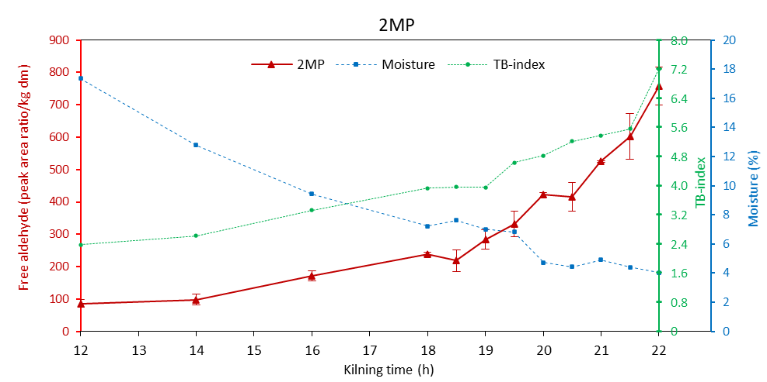 | 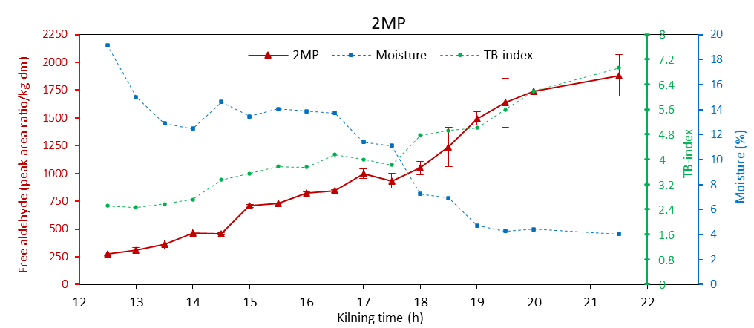
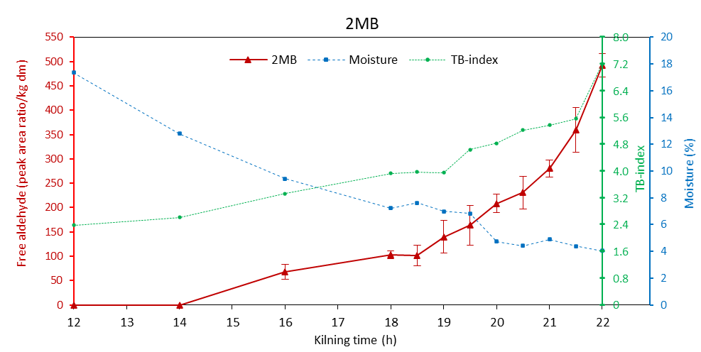 | 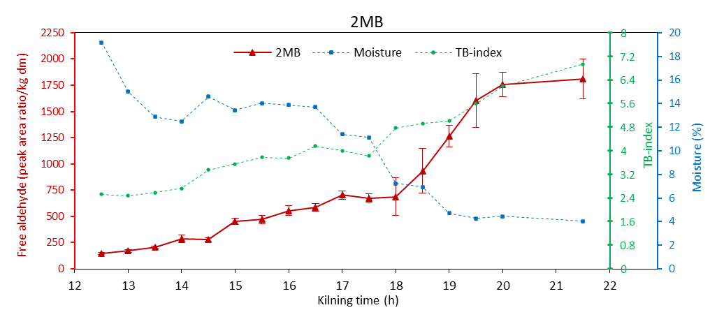
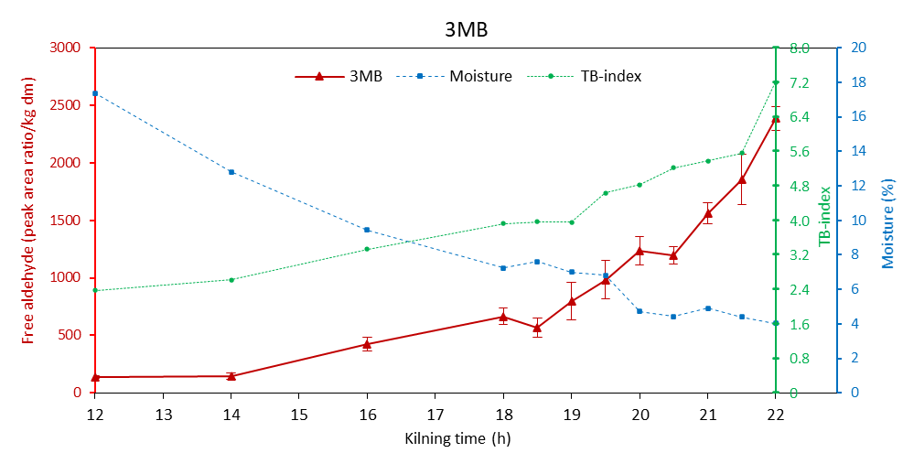 | 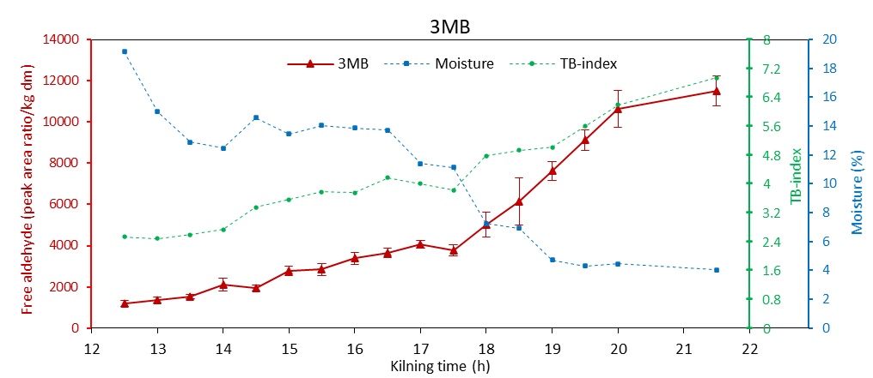
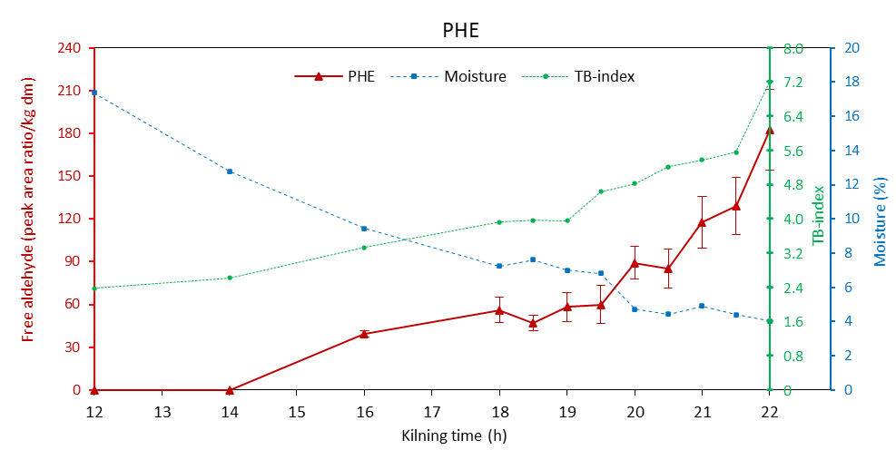 | 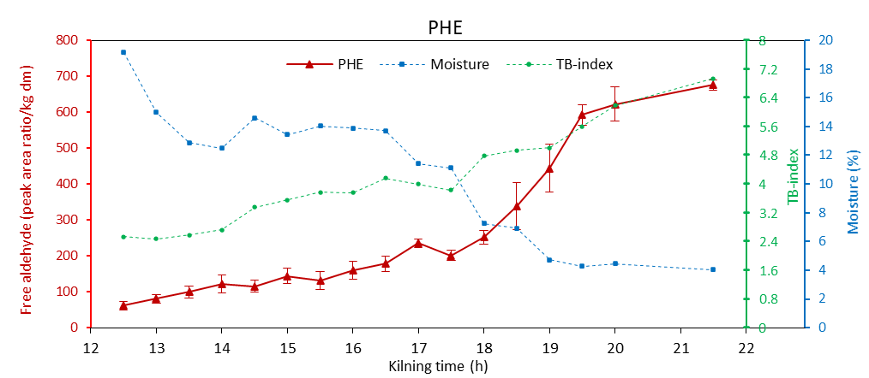
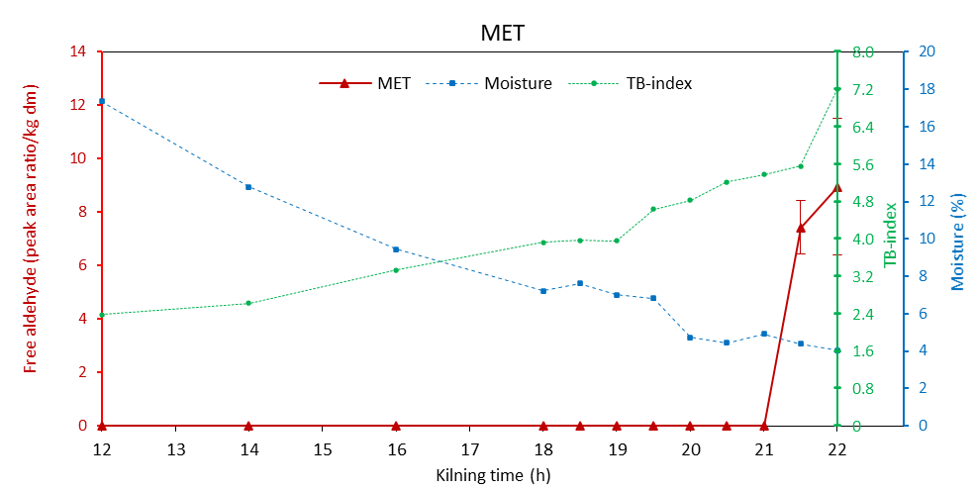 | 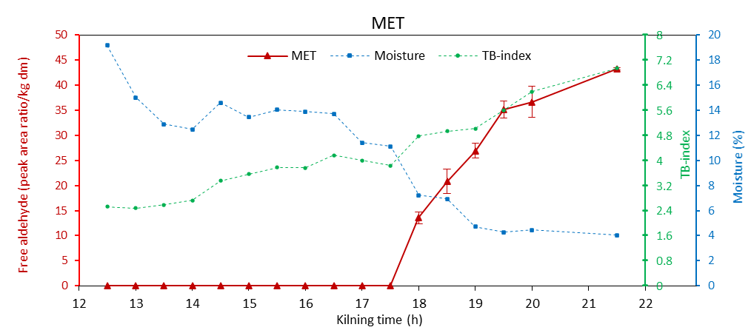
Figure S4.1. Evolution of free Strecker aldehydes in relation to the grain drying process and applied heat load during kilning. Samples collected from the bottom layer.

BOTTOM LAYER
Cysteinylated aldehydes
Kilning A | Kilning b
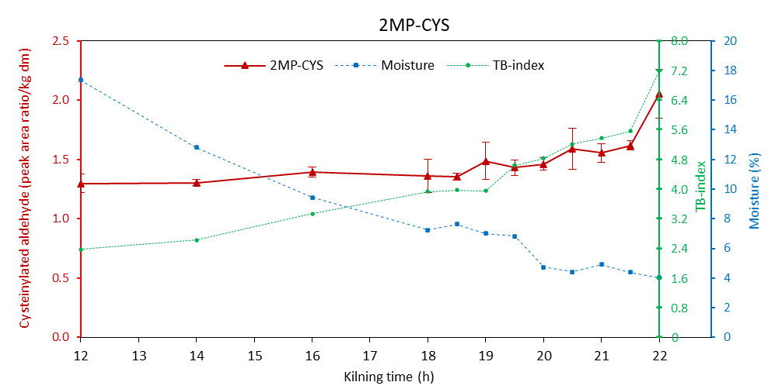 | 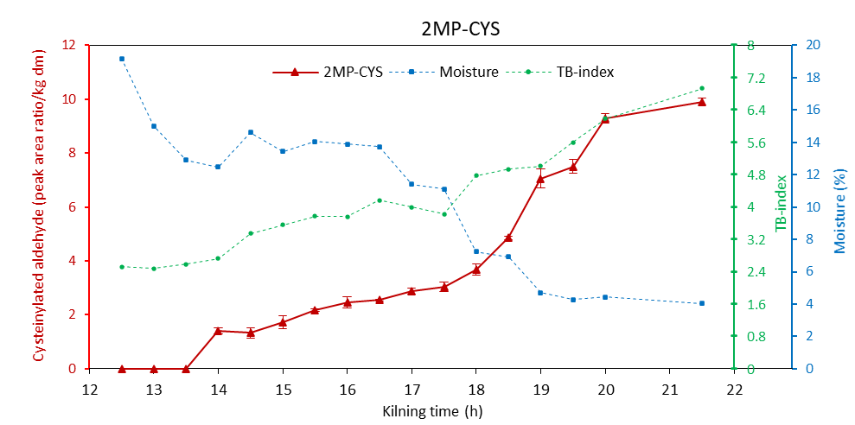
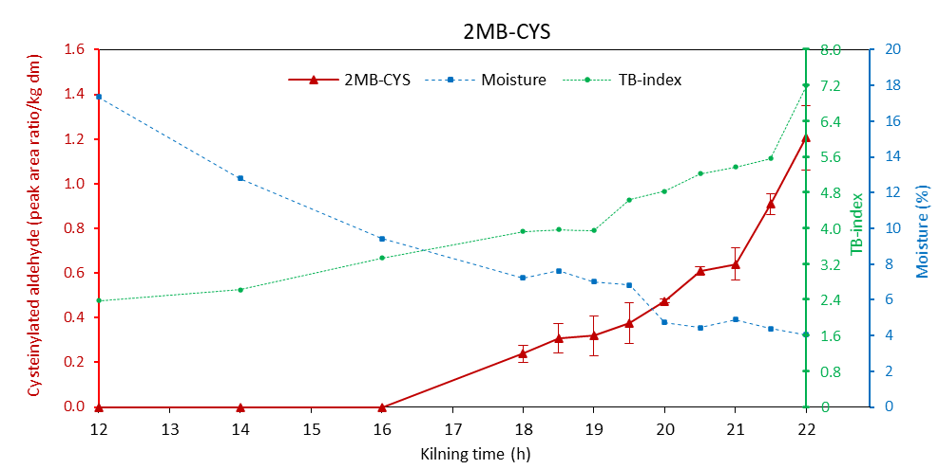 | 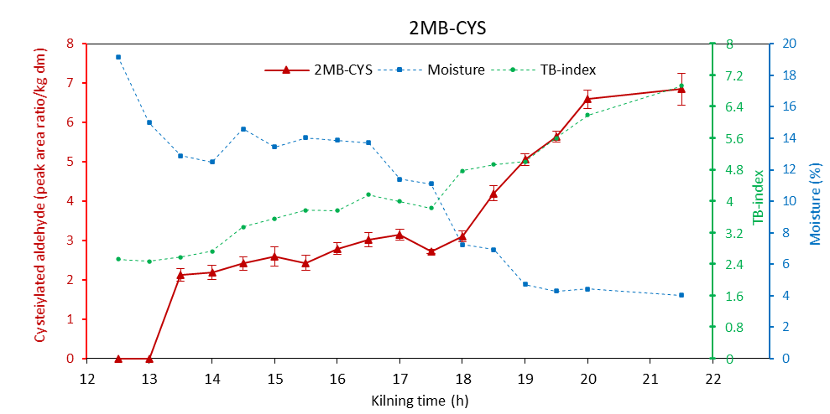
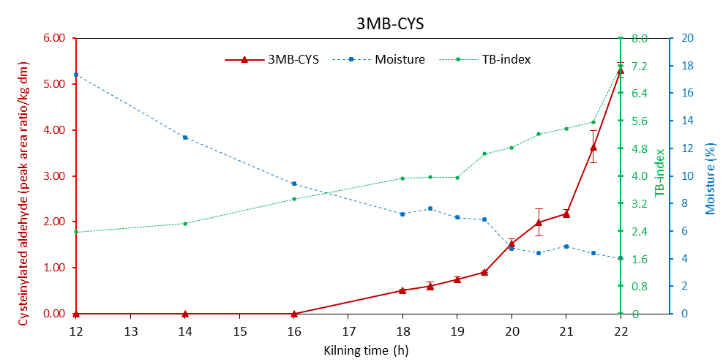 | 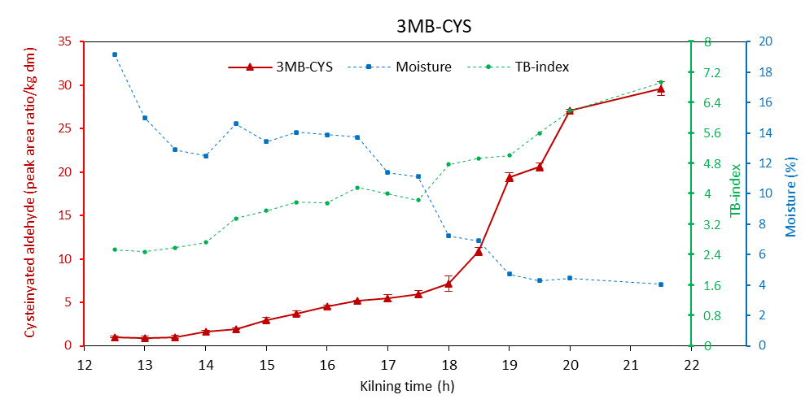
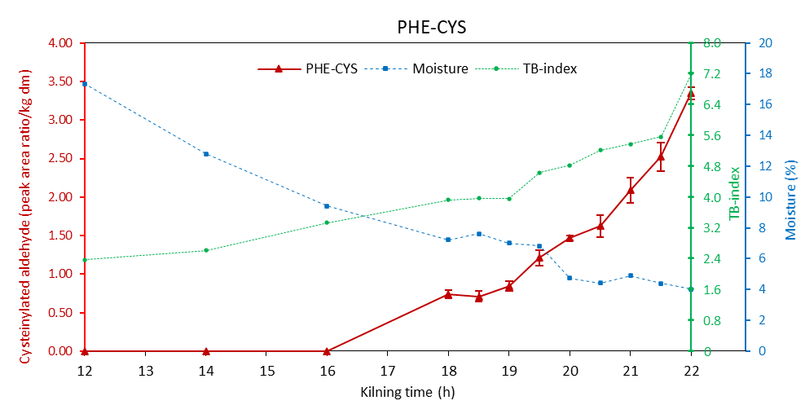 | 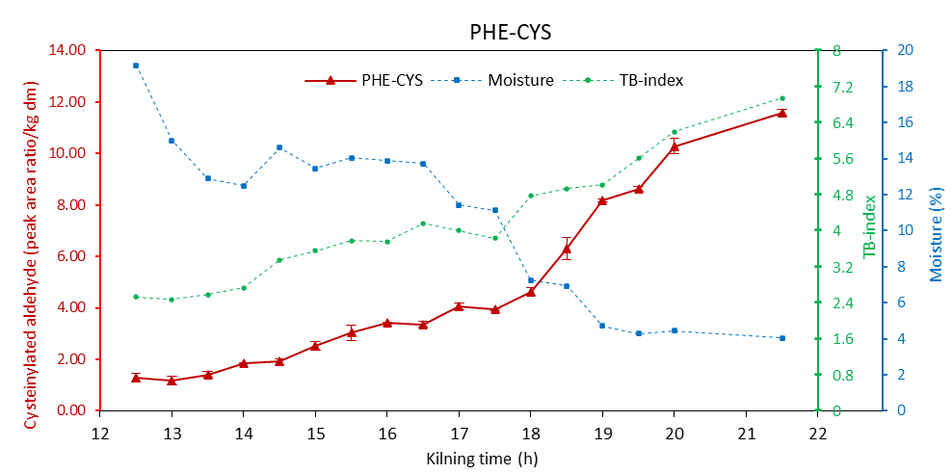
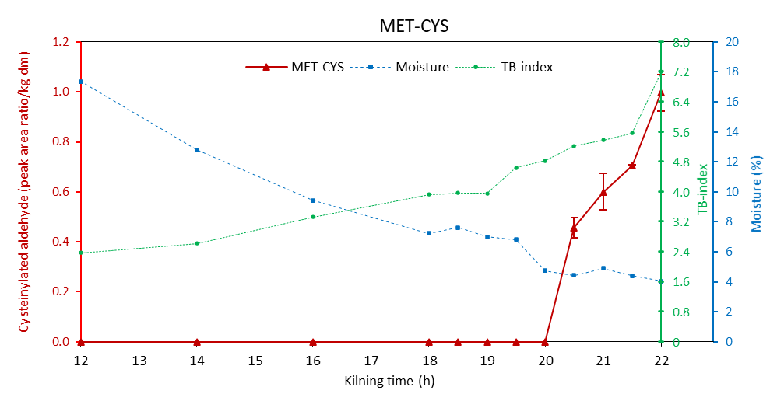 | 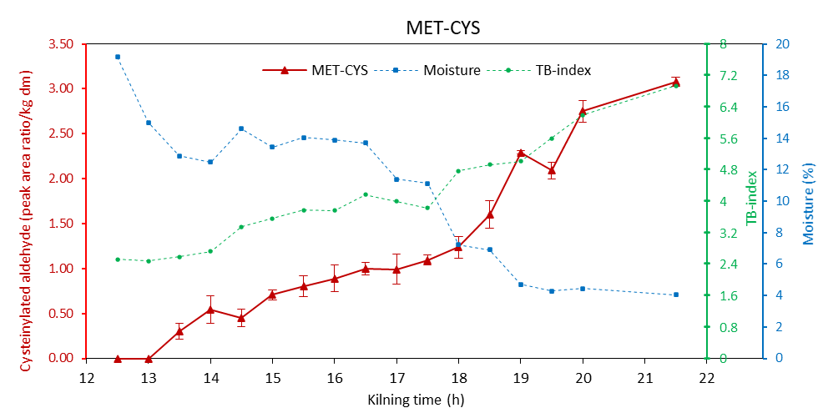
Figure S4.2. Evolution of cysteinylated Strecker aldehydes in relation to the grain drying process and applied heat load during kilning. Samples collected from the bottom layer.

MIDDLE LAYER
Free aldehydes
Kilning A | Kilning b
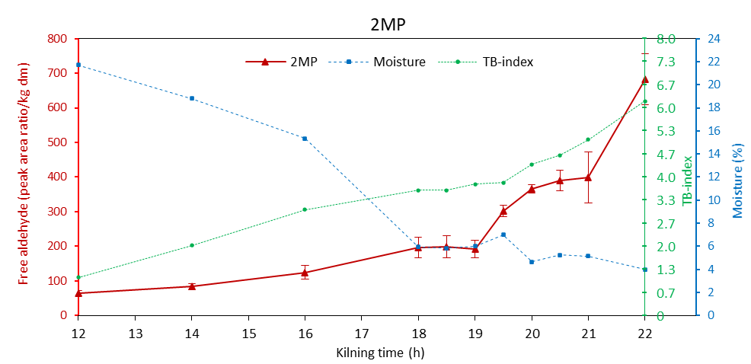 | 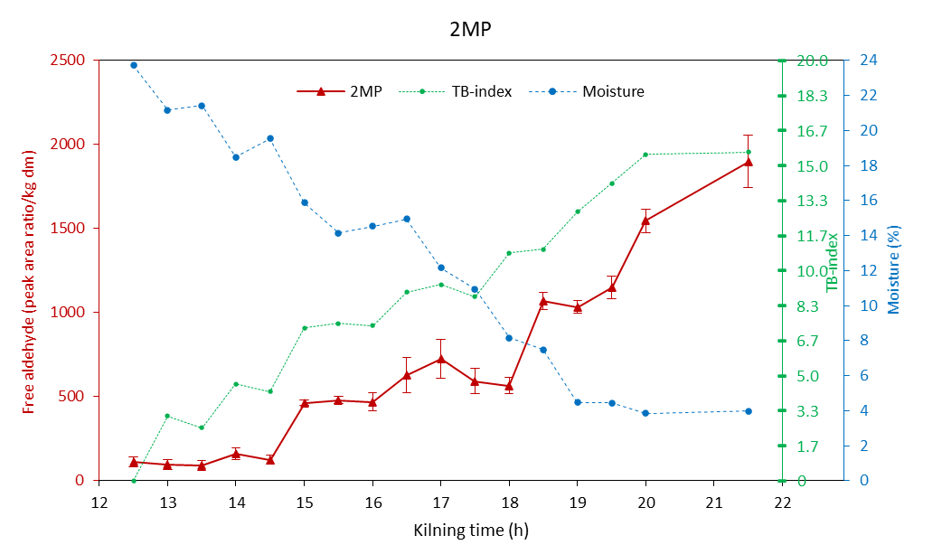
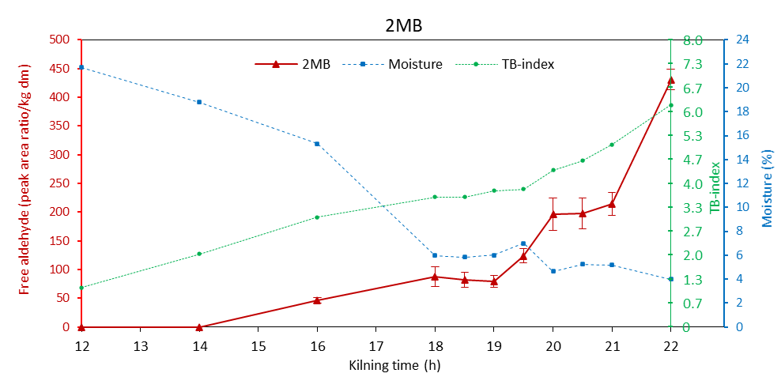 | 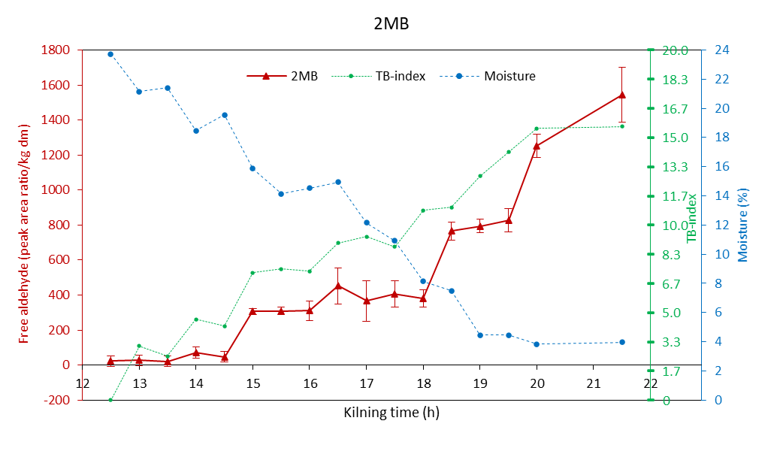
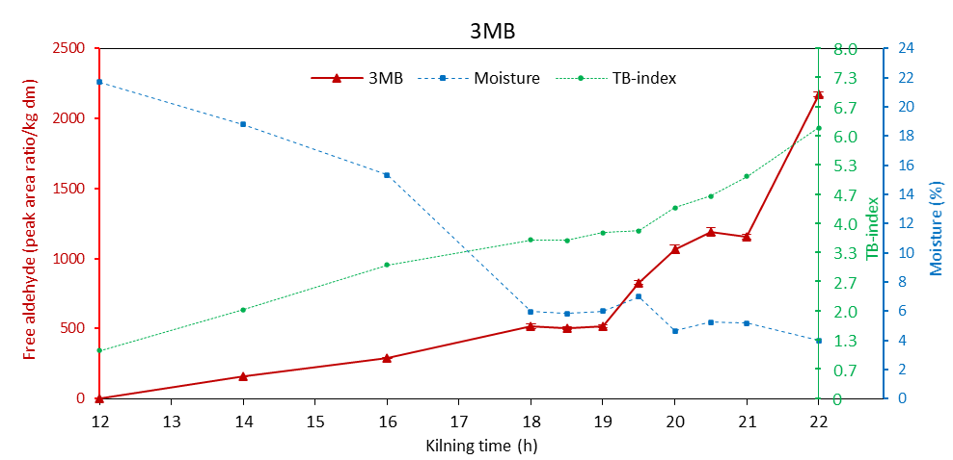 | 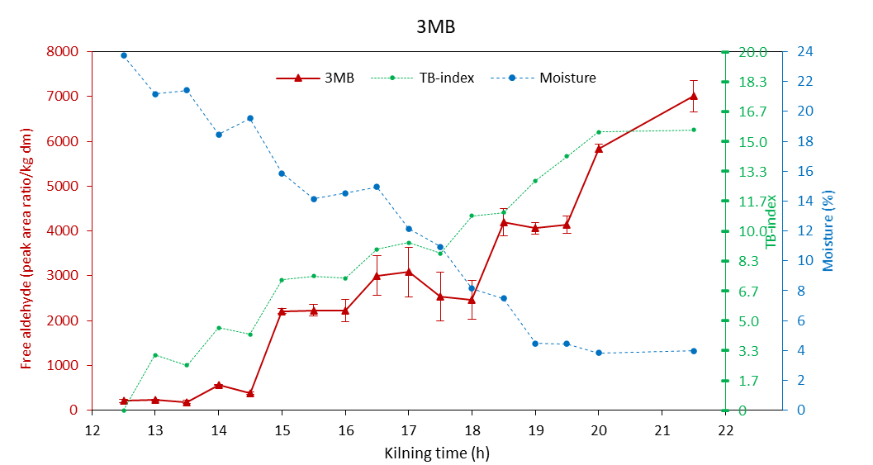
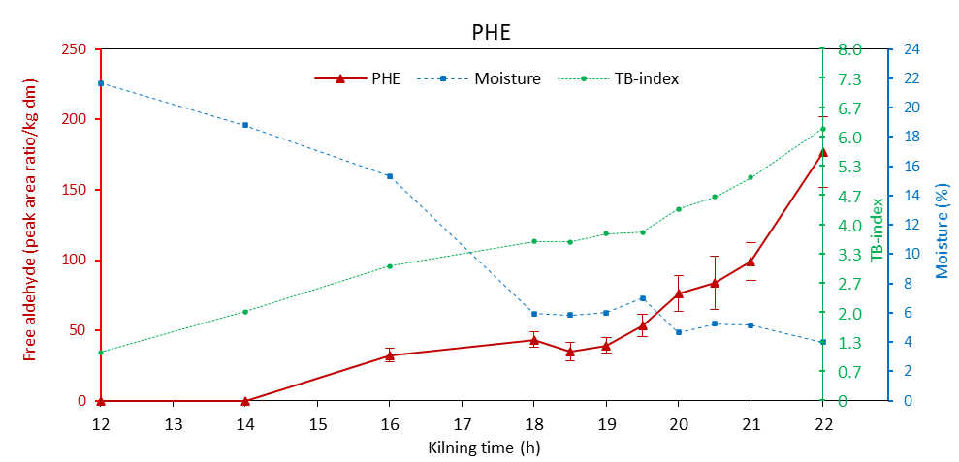 | 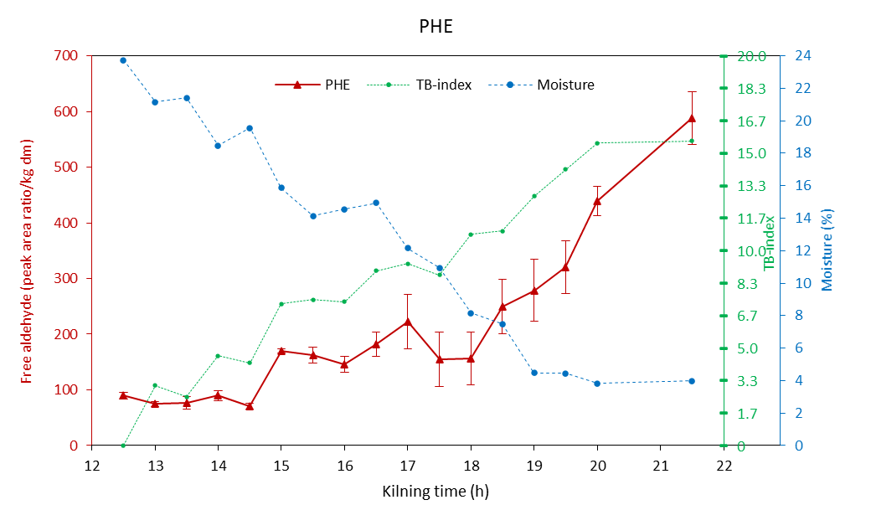
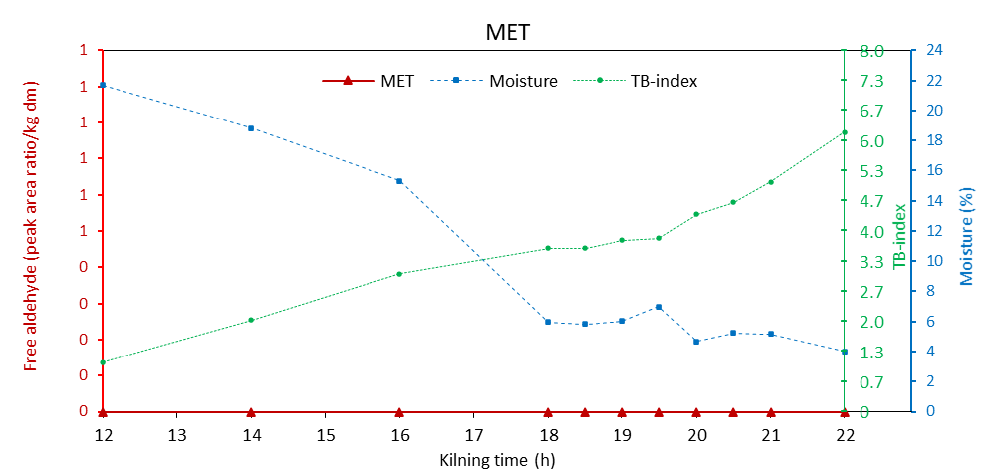 | 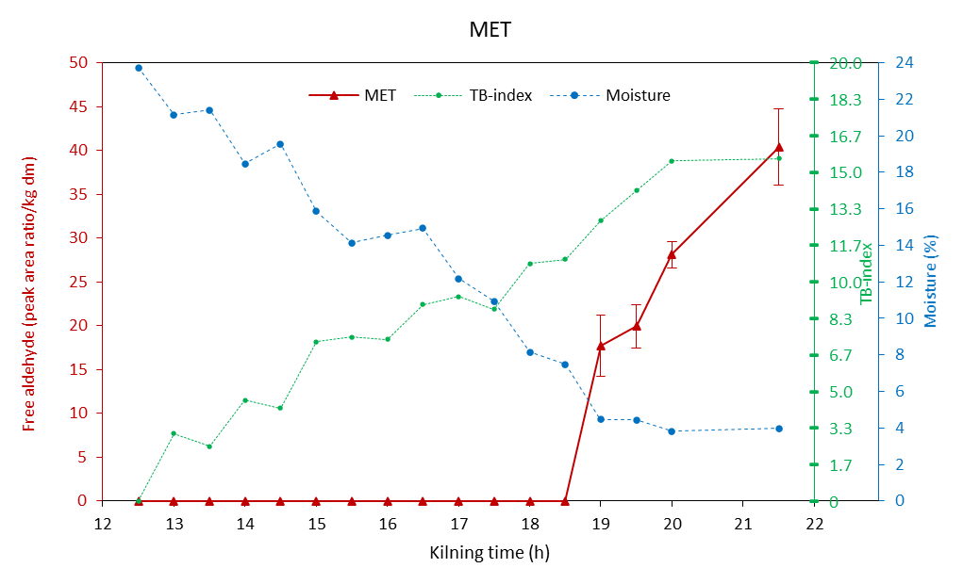
Figure S4.3 Evolution of free Strecker aldehydes in relation to the grain drying process and applied heat load during kilning. Samples collected from the middle layer.

MIDDLE LAYER
Cysteinylated aldehydes
Kilning A | Kilning b
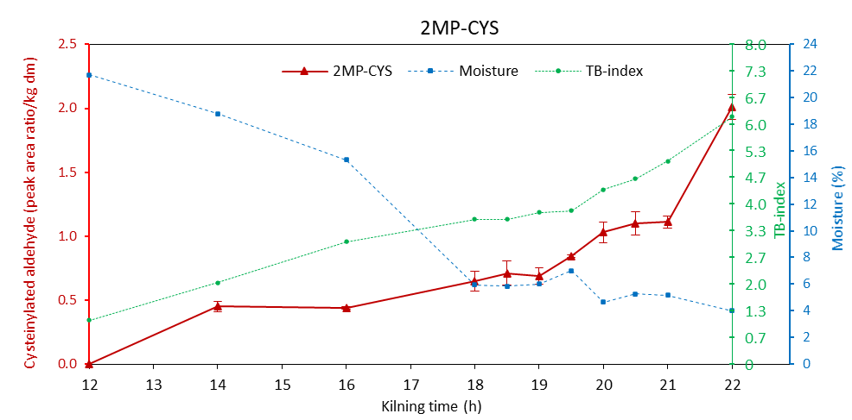 | 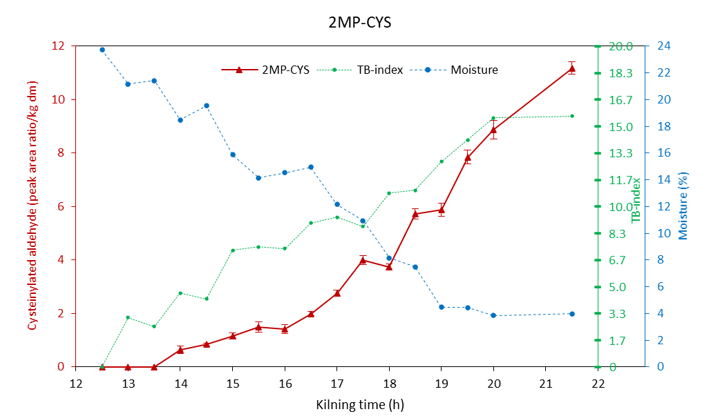
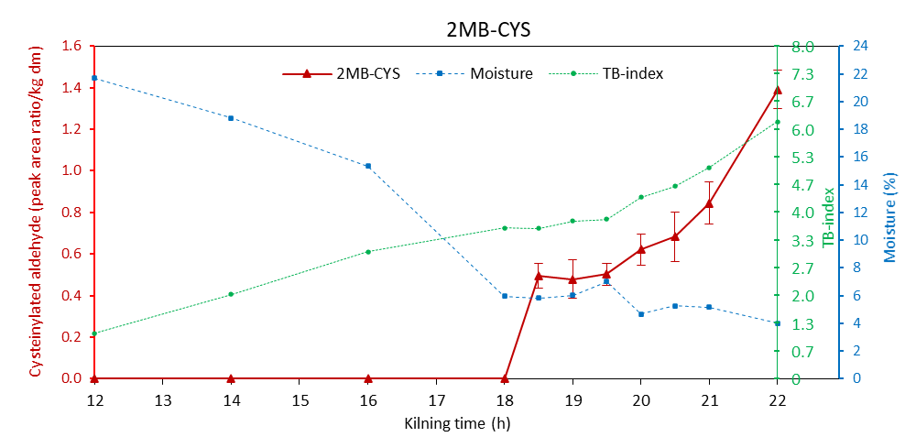 | 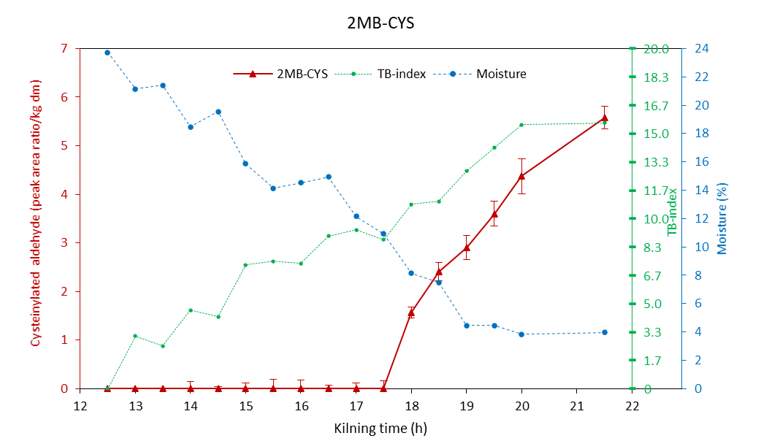
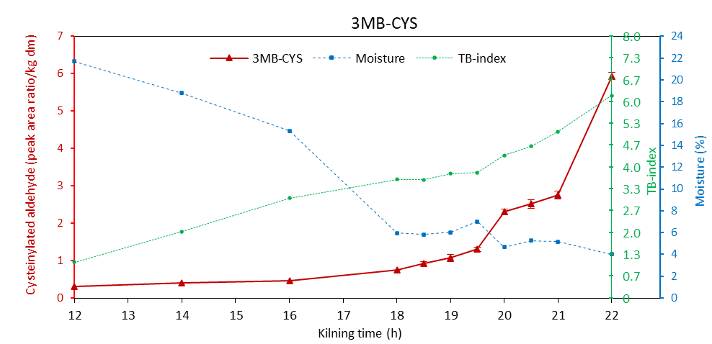 | 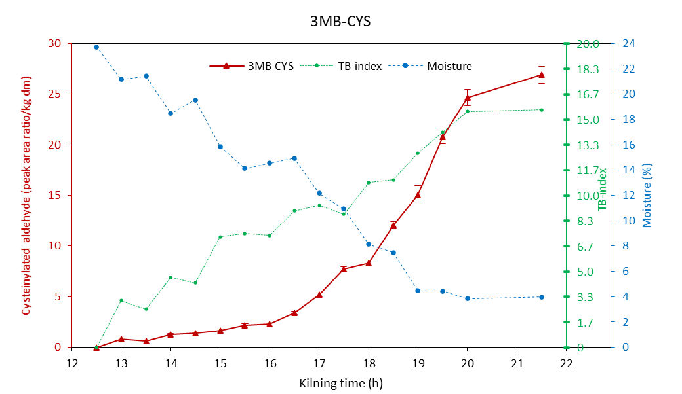
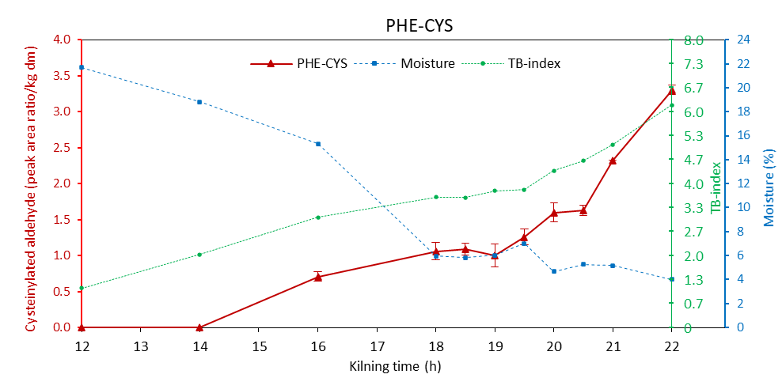 | 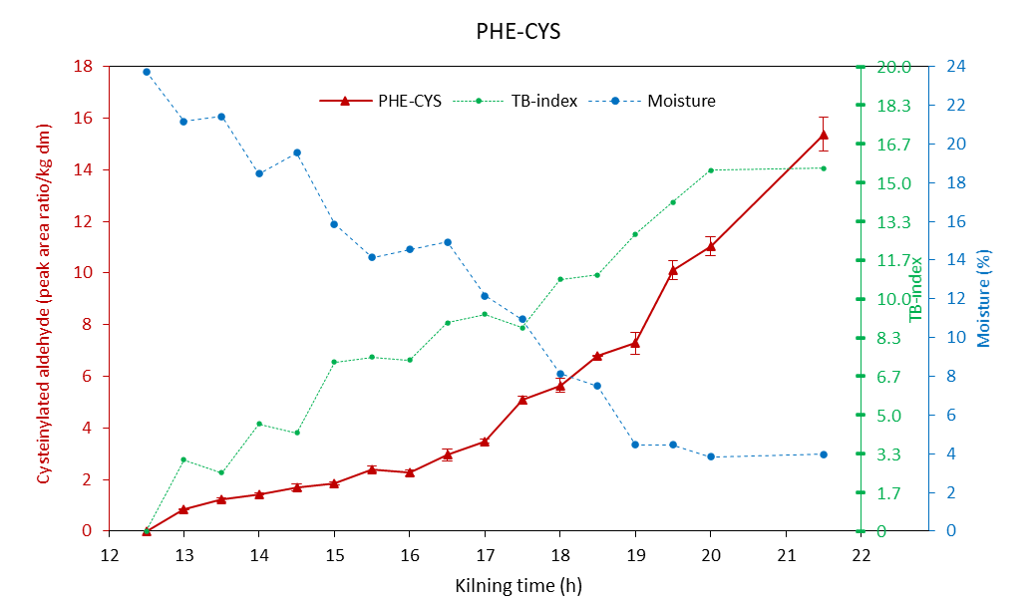
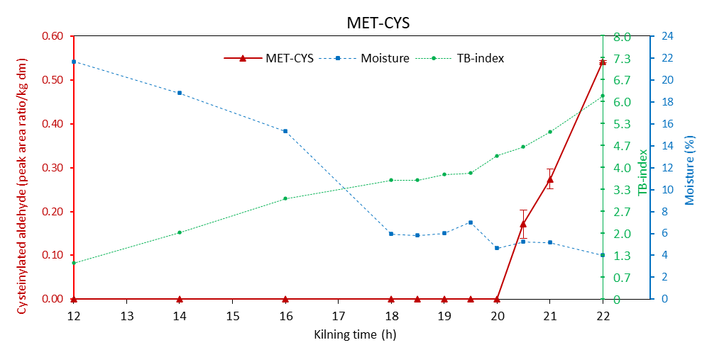 | 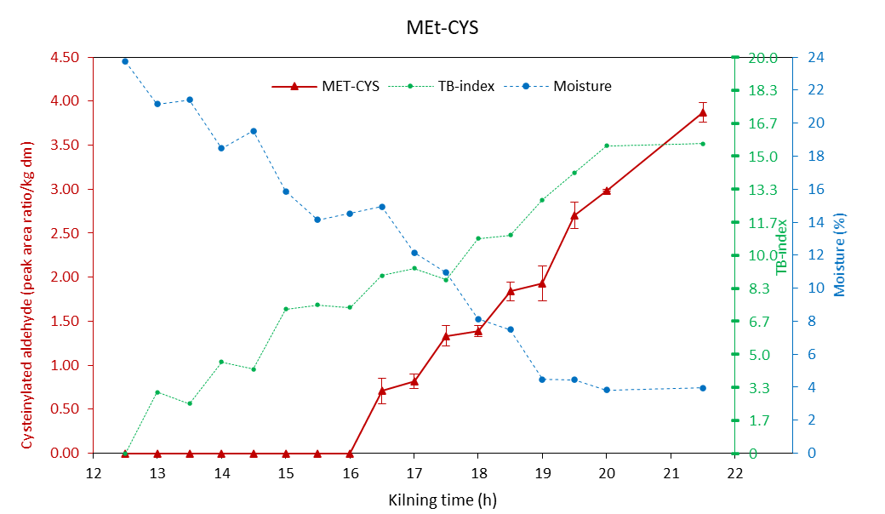
Figure S4.4 Evolution of cysteinylated Strecker aldehydes in relation to the grain drying process and applied heat load during kilning. Samples collected from the middle layer.

TOP LAYER
Free aldehydes
Kilning A | Kilning b
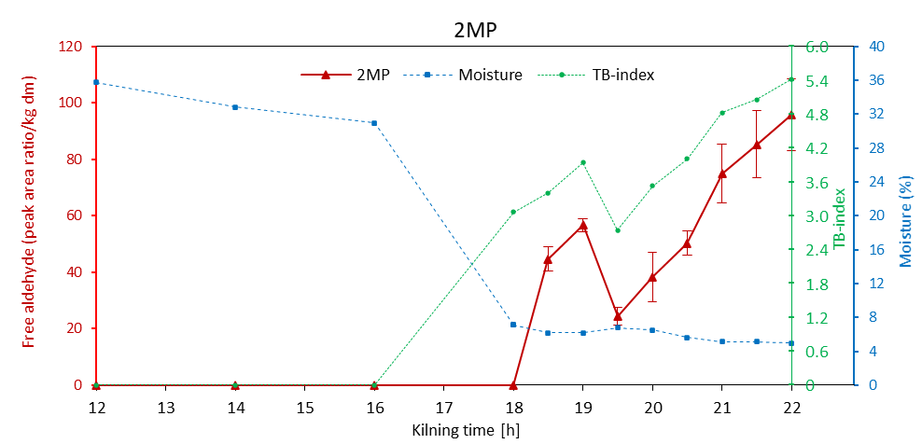 | 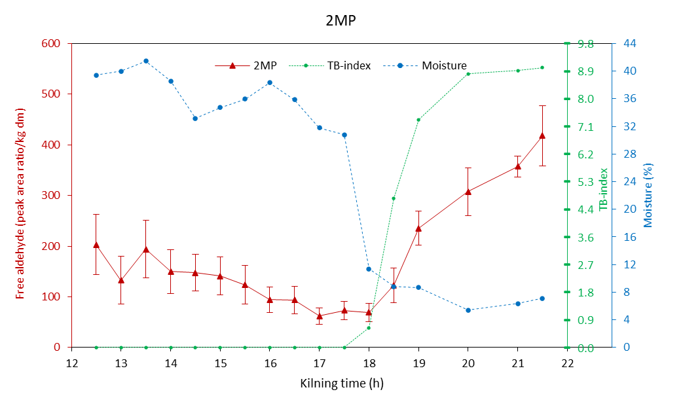
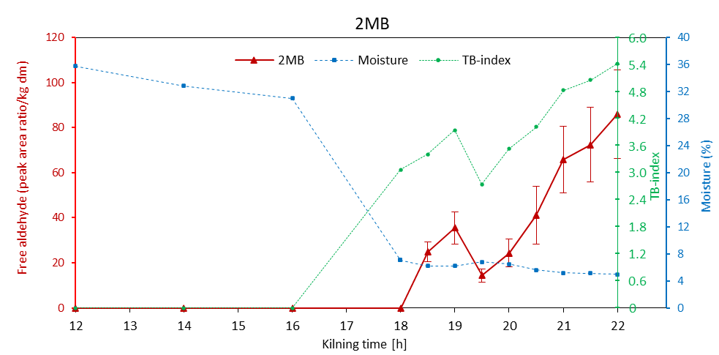 | 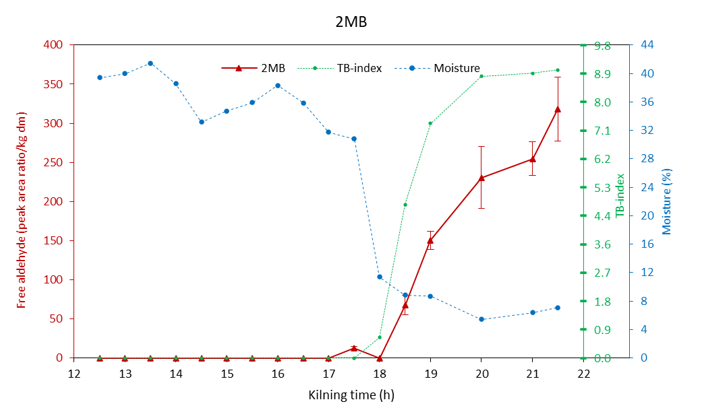
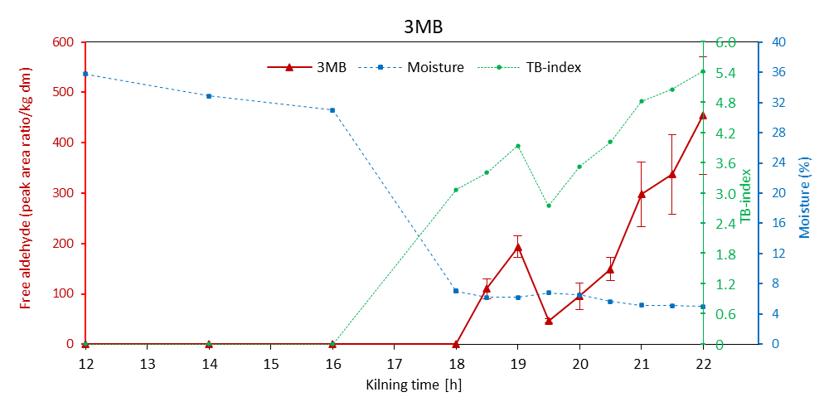 | 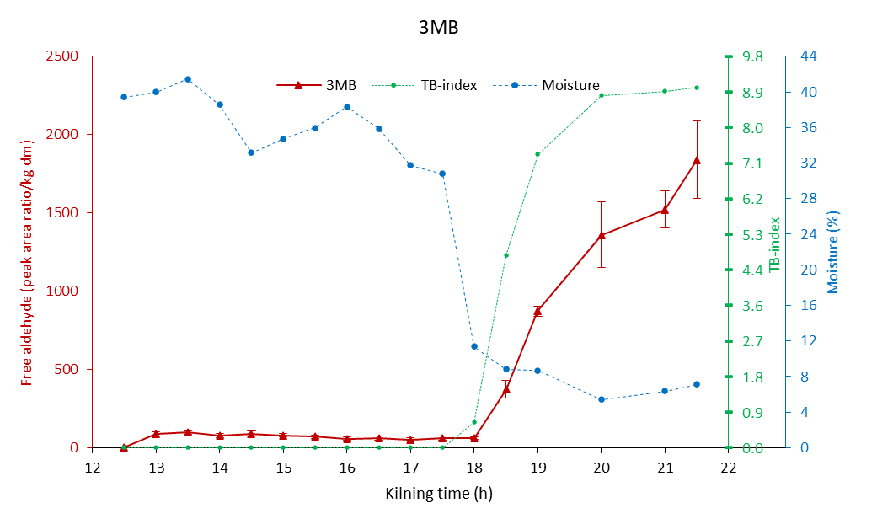
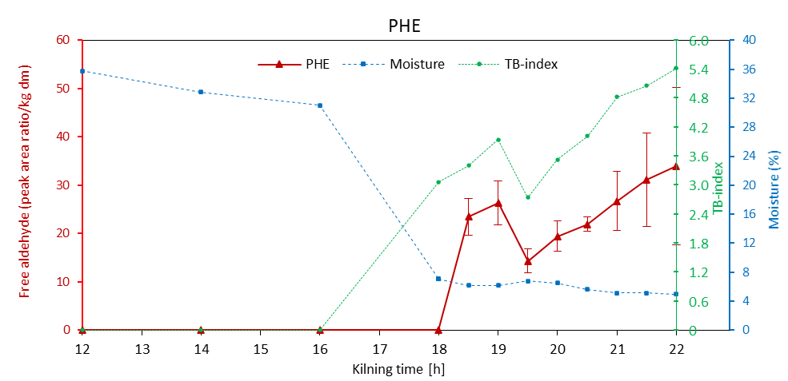 | 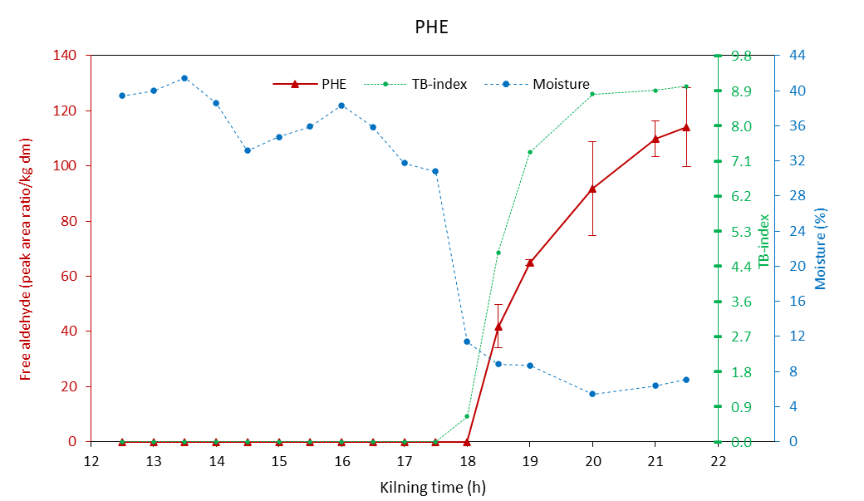
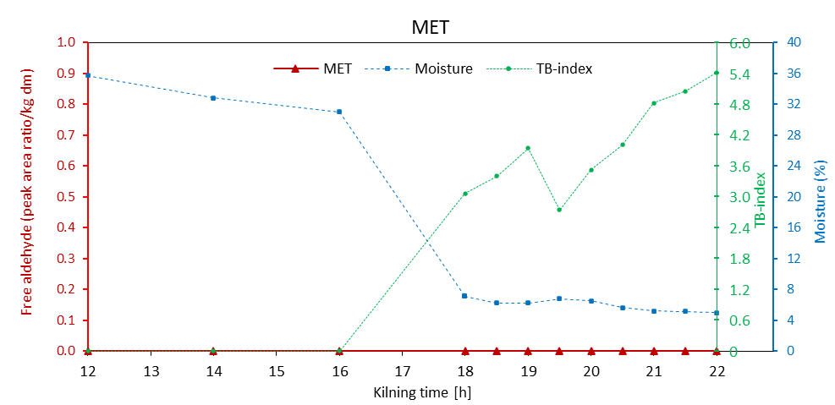 | 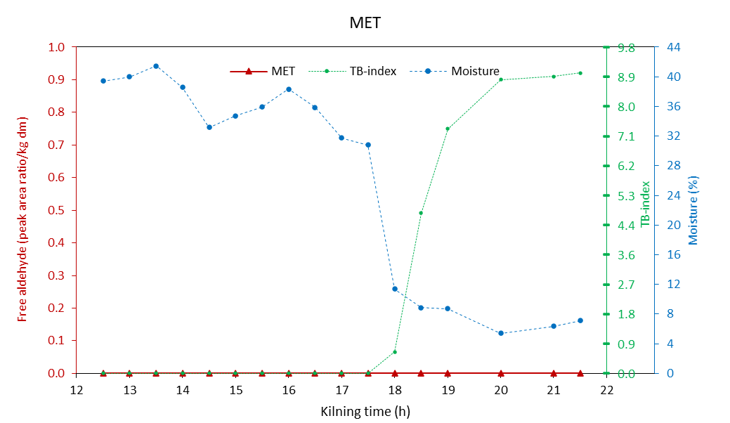
Figure S4.5 Evolution of free Strecker aldehydes in relation to the grain drying process and applied heat load during kilning. Samples collected from the top layer.

TOP LAYER
Cysteinylated aldehydes
Kilning A | Kilning b
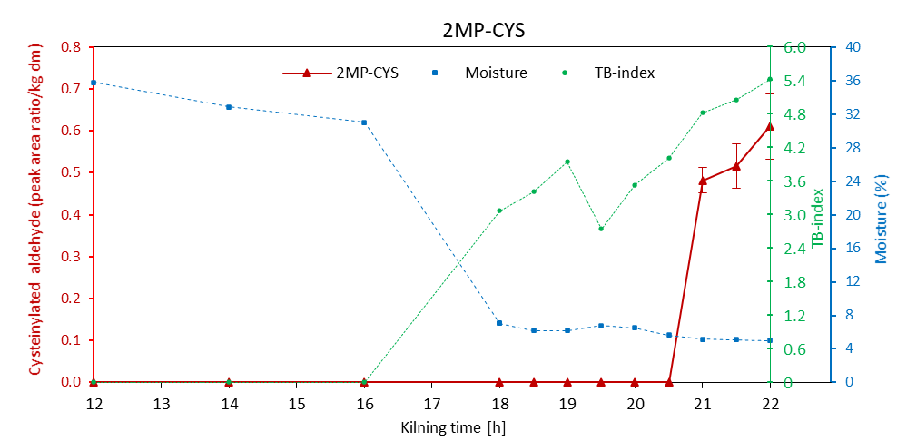 | 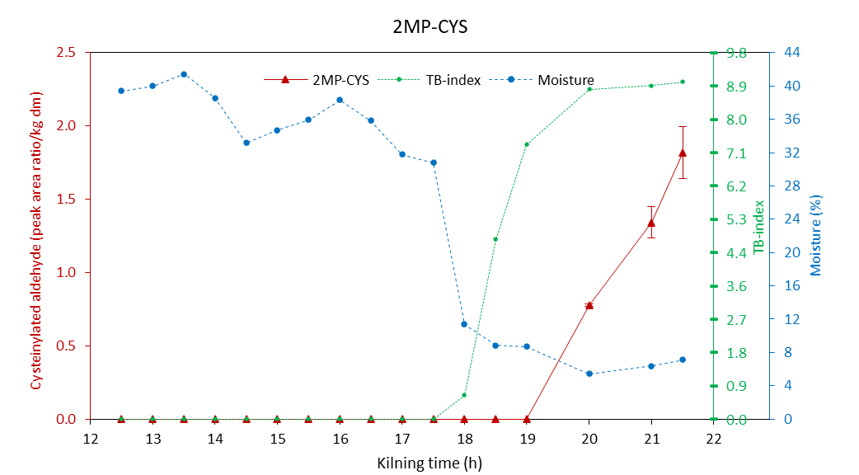
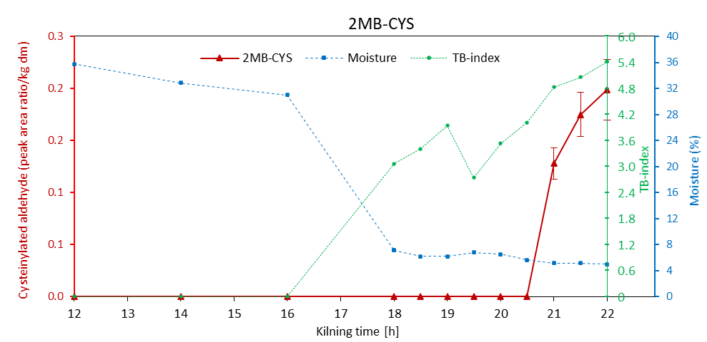 | 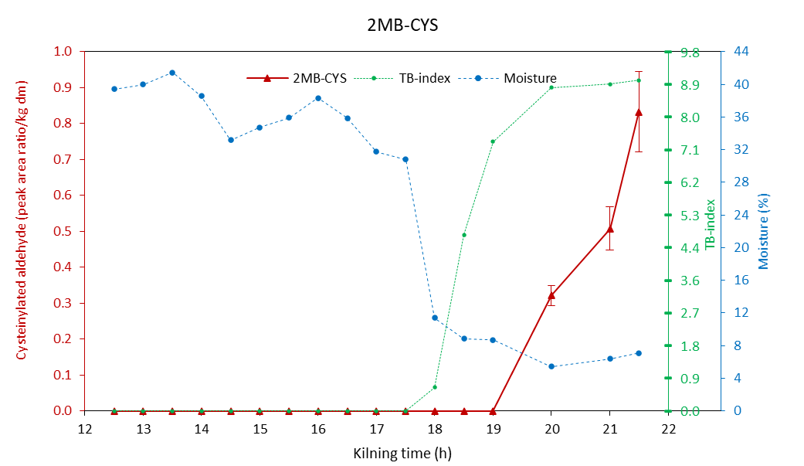
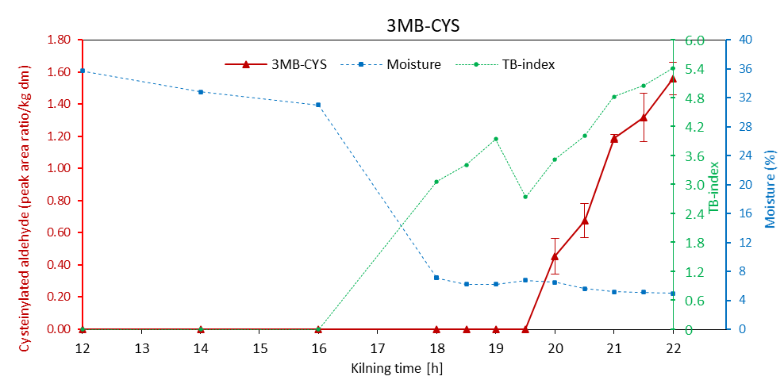 | 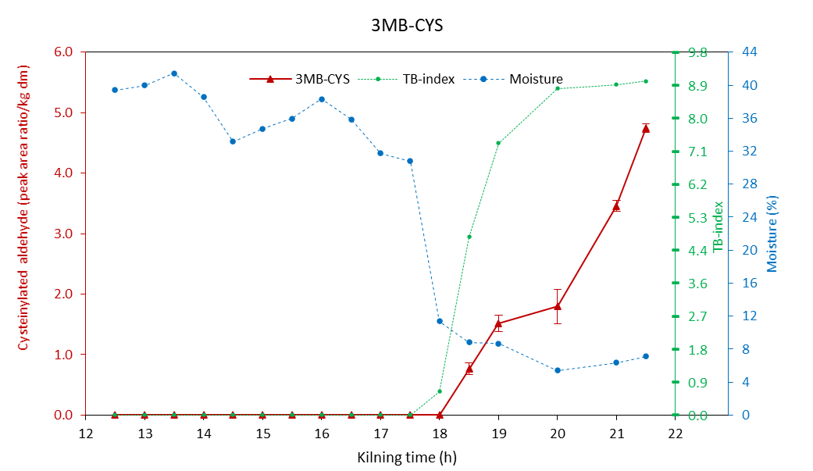
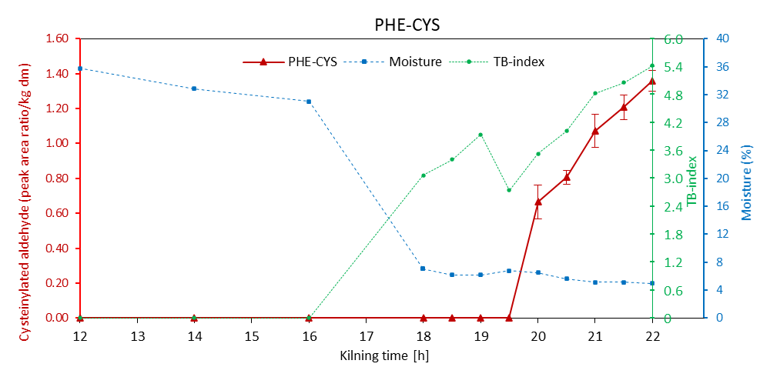 | 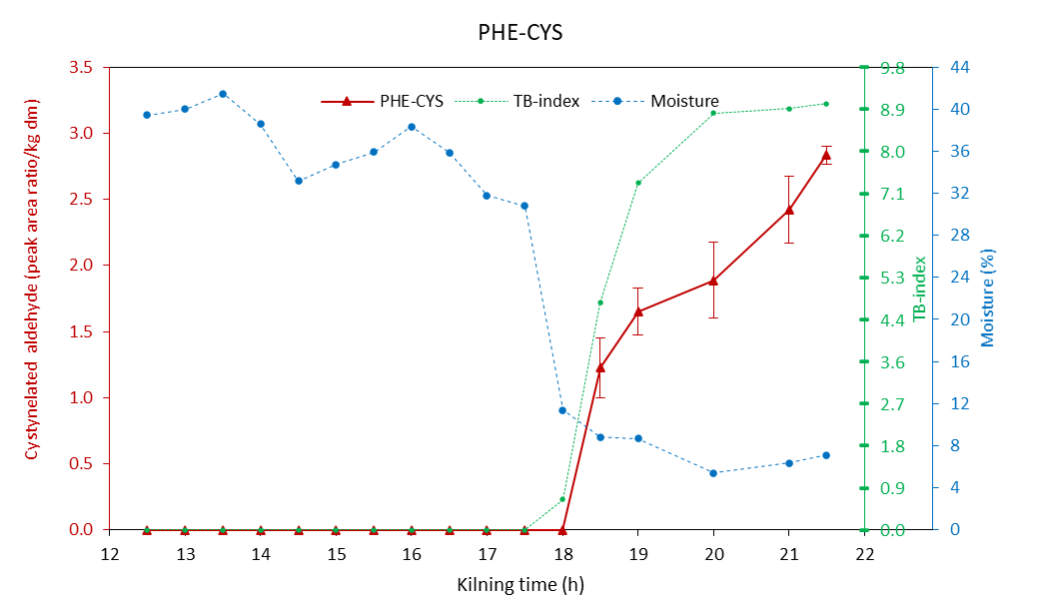
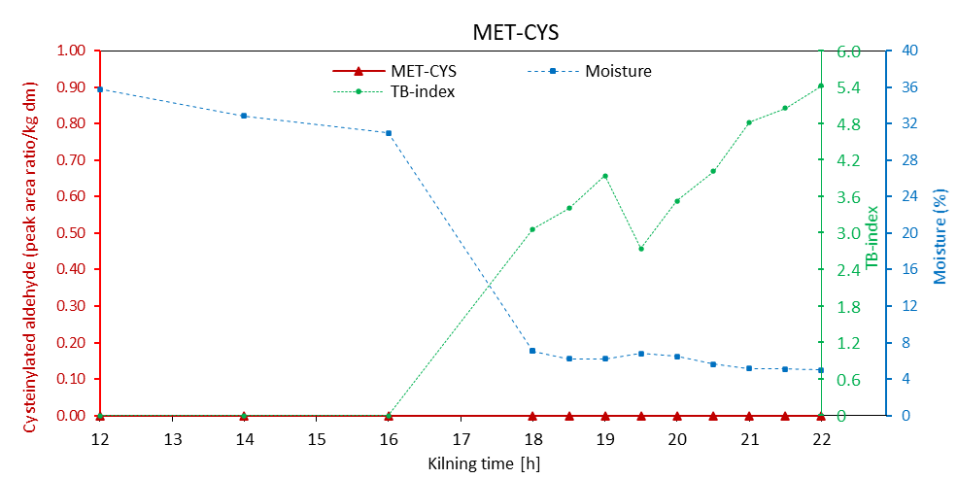 | 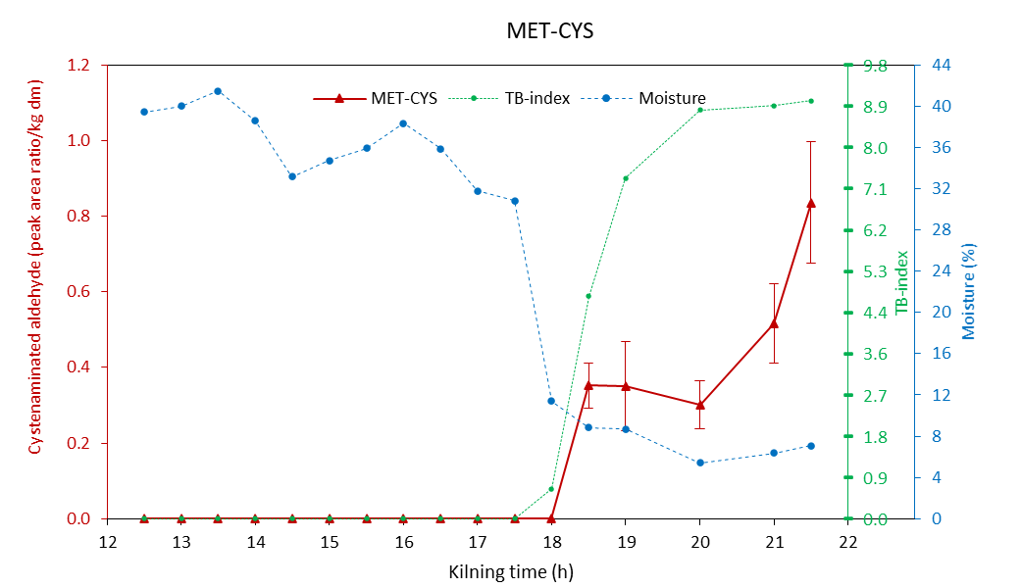
Figure S4.6 Evolution of cysteinylated Strecker aldehydes in relation to the grain drying process and applied heat load during kilning. Samples collected from the top layer.

